Atti II Conv. Int. F.E.A. Pergola, 87 | Pallini et alii cur. | pp. 459-478 8 figg. | Jurassic-Cretaceous Ammonoid ecology

New developments in Ecology of Jurassic-Cretaceous ammonoids
GERD E.G. WESTERMANN McMaster University, Hamilton, Canada L8s 4M1

RIASSUNTO
L 'interpretazione dell'habitat degli ammonoidi è integrata dalla stra-tigrafia, dalla tafonomia e dall'analisi di tutte le strutture disponibili interne ed esteme dell'organismo. Lavori recenti sugli anelli connettivi e sui setti permettono un calcolo della profondità approssimativa alla quale la pressione dell'acqua circostante faceva esplodere gli anelli connettivi ed implodere l'ultimo setto costruito. Dato che gli habitat e la massima profondità raggiungibile degli ecto e endonucleati viventi sono in relazione con la loro rispettiva resistema della conchiglia si possono stimare i parametri ambientali degli ammonoidi. Le stime della mobilità (più lenta o più veloce che in Nautilus.) sono basate svii'efficienza idrodinamica della forma e dell'ornamentazione della conchiglia, mentre quella della stabilità idrostatica sono basate sulla forma della conchiglia, galleggiabilità e distanza dei centri di galleggiamento e di massa. E proposta una funzione locomotrice per gli optici calcitici sottili; un ventaglio posto sotto la massa boccale poteva creare una corrente d'acqua per l'iponoma. I principali habitat proposti per le ammoniti del Giurassico e del Cretaceo sono elencati qui di seguito.
A - Oceanico 1) zona fatica (0-250 m): a) planctonici (alcune pseudolarve); b) epipelagici (alcune forme eteromorfe non spiralate); e) epipelagici-bentonici o «ecto bentonici, conforme mobili (Holcophyl-loceras) — 2) zona afotica (250-800 m): a) mesopelagico con nuotatori passivi come alcuni eteromorfi ancyhconici. b) Mesopelagici, con forme capaci di lente escursioni verticali (Lytoceratidi). e) Nectoben-tonici o mesopelagici, nectonici con forme mobili (la maggior parte dei Phylhceratidi). B. Neritico - 1. Nuotatori passivi pelagici: a) ? alcuni serpenticoni (Dactylioceratidi o 3b-c); b) alcuni eteromorfi non spiralati (ancyloconi, Hamitidi ecc.) - 2. Forme capaci di escursioni verticali: a) ? ortoconi e torticoni (Saculitidi e Turrilitidi o Sa); b) ? ancyloconici, sferoconi (Scaphitidi o 3c) - 3. Necto-bentonici lenti: a) ? saltatori (ortoconi ed alcuni torticoni a rapida fuga; Baculitidi e Turrilitidi); b) forme di acque basse (planulate ornamentate, coronate; Ste-phanoceratidi ecc.); e) ? alcuni Scaphitidi. — 4. Necto-bentonici mobili: a) Oxyconi (Oppeliidi, Placenticeratidi di acque basse come Pla-centiceras fino a profonde come Uhiigites); b) platiconi compressi (Ha-ploceratidi a profondità intermedie) — 5. Nectobentonici o nectonici di piattaforma estema da lenti a mobili: a) omeomorfi platiconi dei Phylloceratidi (Desmoceratidi); b) inflate, in gran parte lisce (Pachyce-ratìdi).

ABSTRACT
Ammonoid habitat interpretation is integrated from stratigraphy, taphonomy and analysis of all available, external and internal organism structures. Recent work on connecting rings and septa permits calculation of the approximate depth at which ambient water pressure exploded the connecting rings and imploded the ultimate septum. Since the habitats of living ecto-and endocochliate cephalopods are related to, and their lower limits correlated with, their respective shell strengths, habitat parameters can be estimated for ammonoids. Estimates for mo-tility are based on hydrodynamic efficiency of shell shape and ornament (slower or faster than NautilusJ; for hydrostatic stability, on shell shape, buoyancy and distance of centres of buoyancy and mass. A loco-motor function for thin, calcified aptychi is proposed, a reciprocating louvre fan beneath the buccal mass creating a current for the hyponome.
The principal Jurassic-Cretaceous ammonoid habitats here proposed

A. Oceanic: 1. Photic Zone f< 250 m): a) Planktonic: some pseudolarvae. b) Epipelagic: some non-spiralic heteromorphs. c) Epipelagic-nektonic or nekto-benthic, mobile: Holcophylloceras. — 2. Aphotic Zone (250-800 m): a) Mesopelagic, drifters: some ancycloconic heteromorphs. b) Mesopelagic, vertical migrant, sluggish: Lytoceratids. c) Nek-fobenthic or mesopelagic, nektonic, mobile: most Phylloceratids. B. Neritic: 1. Pelagic drifters: a) ? Some serpenticones: Dactylioceratids (or 3b-c). b) ? Some non-spiralic heteromorphs: ancylocones, Hamitids, etc. — 2. Vertical migrants: a) ? Orthocones and torticones: Baculitids, Turrilitids (or 3a). b) ? Ancyloconic spherocones: Scaphtids (or 3c).
— 3. Nekto-benthic, sluggish: a) ? Saltatori: orthocones and some torticones (with rapid escape); Baculitids, Turrilitids. b) Shallow: Ornate planulates and coronates; Stephanoceratids, etc. c) ? Some Scaphitids.
— 4. Nekfo-benthic, mobile: a) Oxycones: Oppeliids, Placenticeratids, from shallow (Placenticeras) to deep (Uhligites). b) Compressed platy-cones: Haphceratids, intermediate depth. — 5. Nektobenthic or nektonic, outer shelf, sluggish to mobile: a) Platyconic homeomorphs of Phylloceratids: Desmoceratids. b) Inflated, mostly smooth:
Pachyceratids.

KEY WORDS
Ammonoids, ecology, Jurassic, Cretaceous, functional morphology.

INTRODUCTION
Near Pergola in the central Apennine, the seat of this conference, are the famed Tithonian (latest Jurassic) ammonite localities of Monte Catria and Monte Nerone. One and a quarter centuries ago, they were examined by the celebrated German palaeontologist Karl A. (von) Zittel guided by the Italian monk Raffaele Piccinini. These Tithonian assemblages seemingly include ammonoids of contrasting habitats, i.e. neritic shallow-water "trachyostracans" and oceanic deep-water "leiostracans". This problem of distal platforms is one of the topics discussed below. In the last few years, work on ectocochliate cephalo-pod ecology has made great strides on three fronts. Firstly, research was concentrated on the living Nautilus. Two major works are in press while this article is being written; the comprehensive, multi-authored effort by W. Bruce Saunders and Neil H. Landmann (Plenum, New York), the former one of the principal observers of Nautilus habitat; the other book is by Peter Ward (Alien & Un-win, London) on his own rich and original field observations and laboratory experiments. Although the reason for this bloom of Nautilus research by paleontologists is at least partly the better understanding of ammonite anatomy and paleoecology, there has been doubt among specialists about the adequacy of Nautilus anatomy and behaviour as a modern analogue to the extinct ammonites.
Secondly, the research on fossil nautiloids and ammonoids has entered the analytical stage in which rigorous methods from physics and engineering are applied to cai-

FOSSILI, EVOLUZIONE, AMBIENTE - G.E.G. WESTERMANN
460

cified and chitinous parts of the skeleton. Among recent works are those by Chamberlain (1981), Hewitt (1985), Hewitt and Westermann (1985), 1987 a-c, 1988 a, b), Leh-mann (1981), Reyment (1980), Saunders & Shapiro (1984), Saunders & Swan (1984), Swan & Saunders (1987), Tanabe (1983), Ward (1980, 1981, 1982, 1985a), Ward & Westermann (1985), and Westermann (1982). Laboratory experiments on Nautilus tests which appear to be essentially the same as ammonoid tests, identified the physical parameters required for the calculation of shell strenght against implosion by ambient pressure. These experiments also confirmed the validity of the much debated Septal Strength Index devised for primitive nautiloids (Westermann, 1973), and a modified index has now been developed for the ammonoid septum permitting estimates of habitat limits (Hewitt & Westermann, 1987a). Similarly, the old Siphuncular Strength Index (Westermann, 1971) has also been modified and validated (Hewitt & Westermann, 1987b), motivated by critical experiments of Chamberlain and Moore (1982).
Thirdly, recent synecological studies and basin analyses have been carried out, for example in the Jurassic-Cretaceous of Japan (Tanabe, 1979), Germany (Bayer & McGhee, 1984; Kemper, 1987), Switzerland (Gigy, 1986), France (Marchand etal., 1985), Poland (Marcinowsky & Wiedman, 1985), England (Donovan, 1985), Spain (Se-queiros, 1984), Algeria (Elmi, 1984; Elmi & Almeras, 1985), the classical Western Interior Seaway and its Jurassic precursor of North America (Batt, 1986; Taylor, 1982) and its west coast (Ward, 1985, 1986). Significant bio-associations of taxa and morphotypes are indicated.
Many of the contradictory conclusions on ammonoid ecology are due to the consideration of one or two shell parameters only. Ammonoid habitat interpretation should be a synthesis of all known shell structures and their ontogeny (Ward & Westermann, 1985) and in addition of lithofacies, life assemblages and burial conditions, on a case-by-case basis, i.e. usually by taxon of a single basin. Homeomorphy of the shell does not necessarily imply analogy of habitat, but at best similar behaviour in certain respects. For example, the well "streamlined" oxycones were presumably all relatively good swimmers, but their habitat probably varied from inner neritic shallow embay-ments to the edge of the continental shelf, and from nekto-benthic to nektonic. In particular, there are few shell-structure indications to distinguish between a nekto-benthic and nektonic habitats, with the exception of the extreme heteromorphs; or between horizontal swimming and diurnal vertical migration (Tintant et al., 1983) (although the latter is inferred for deepwater forms from arguments based on cameral liquid transport).
Taphonomy. — Post-mortem drifting of ammonoid shells has played a smaller role than customarily assumed and was a significant factor probably only in large forms and/or growth stages (Chamberlain etal., 1981). This argument, however, is largely based on the assumption that the permeability of the connecting rings permitting sea water to flood the empty shell, was similar to that of Nautilus. If "maturation", i.e. reduction of permeability at the end of growth, was more developed in ammonoids than in Nautilus, perhaps by phosphatization (Hewitt & Westermann, 1983), then the adult (fully grown) shells would again have preferred drifting potential. Interestingly, the flow rate of sea water through the connecting rings varies
inversely with the same factors that govern "siphuncular strength" against explosion, i.e. the ratio of wall thickness (b) to tube radius (r). Therefore, if diverse shells of similar size become "empty" at the "design" depth, i.e. the animal dying at equivalent relative depths within their vertical habitat ranges, the chambers would tend to flood at similar rates. For example, the flooding rate of the Lytoceras phragmocone at 600 m depth with a siphuncular strength index (SSI) 100 h/r = 18 is expected to be roughly similar as that of Placenticeras at 100 m depth with SSI = 3. This has, therefore, an important implication: diurnal vertical migrants would preferentially drift if they die in the upper part of their range; they flood more slowly, compared to death in the lower part of their range as well as to non-migrants (neritic nekto-benthic forms). Good examples are the deep-water Desmoceratids and many heteromorphs of the Western Interior Seaway (Batt, 1987), as well as the gigantic Phylloceratids, mainly Holcophylloceras, found in near-shore bivalve assemblages of the Georgian S.S.R. (Khimchiachvili, 1987 and pers. commun). Shell shape with respect to orientation and hydrostatic stability is also related to drifting, by the relative potential to trap air and thus keep water from entering, as for example in many heteromorphis (Batt, 1987). But this becomes a significant factor only after the shells have reached the surface, i.e. gas compression by ambient pressure is minimal.

FUNCTIONAL INTERPRETATION OF PRESERVABLE STRUCTURES
Discussion of the possible functional adaptations of the preservable structures of ammonites proceeds, as usual, from the external shell characters obvious to the general observer, to internal structures. These latter include the septa with their sutures, the connecting rings of the siphuncle usually requiring preparation, and the calcareous and chitinous and phosphatic parts of the buccal mass (Lowenstam et al., 1984), i.e. anaptychi, aptychi and radulae. It is noteworthy, that the external shell characters also remain the most problematic in terms of their functional interpretation, whereas the internal, integral parts of the "buoyancy system", septa and connecting rings, have recently become regarded as a direct means of estimating the habitat depth. Keeping in mind this risk of functionally analysing single structures stressed above, I will nevertheless attempt to do so.
Ammonites with symmetrical shells could presumably swim, propelled by the hyponome, either even more slowly than Nautilus (here called sluggish) or at about the same to a somewhat higher rate (here called mobile). The organism was presumably neutrally buoyant, or slightly negatively buoyant where vertical migration is involved as in Nautilus, the hyponome being in a similar position. Reyment (1980) has experimented with shell models of different normally coiled ammonoids made of copper-plated plastic, and found that the models were all markedly positively buoyant unless the equivalent weight of cameral liquid filling the last 3 or 4 chambers was added. The implied inefficiency, i.e. "over-design" of the shell, however, appears unlikely and contradicts our own, somewhat similar experiments on heteromorphs (see below). Neutral buoyancy has also been calculated for Carboniferous ammonoids (Swan & Sauders, 1987). On the other hand, Ebel's (1985)

JURASSIC-CRETACEOUS AMMONOID ECOLOGY
461

gastropod-like, benthic crawler model for all ammonoids is based on his own earlier spurious density calculations (Ebel, 1983) according to which all were negatively buoyant. But his data on ammonite whorls, transformed into polygonic gnomons, fall within a 10% error of neutral buoyancy. He then proceeds to "explain" ammonite shell shape, based on the (incorrect) assumption that the growth gradients across the peristome controlling the growth spiral vary according to the alleged stresses.
The hydrodynamic efficiency of planispiralic shells has been estimated mainly by Chamberlain (1981 and earlier), but absolute drag coefficients for real shapes are hard to come by, and scaling for the animal (volume, without shell) was perhaps not fully realized. As expected, strongly compressed and involute shells (high aspect ratio) have the lowest drag coefficient, evolute and depressed shells the highest. Furthermore, ovate whorl cross-sections have lower drag than circular or elliptical ones. The influence of "ornament" (sculpture) is discussed under that title below.
The locomotor in Nautilus is mainly the paired large retractor muscles which, by pulling on the cephalic mass, reduces mantle cavity volume, thus expelling water through the hyponome — and rocking the organism (Chamberlain, 1981). The funnel lobes of the hyponome in the anterior mantle cavity probably contribute only slightly to the jet force during rapid movement, but would be expected to produce a more even jet stream at much lower velocity. Typically long and thin ammonoid body chambers, however, would make the Nautilus-like pumping actions of the head inefficient and probably unfeasible. A special type of pump is therefore tentatively proposed below for ammonoids with thinly calcified aptychi.
In the Ammonitina and Lytoceratina, the retractor is well known to have been inserted postero-dorsally within the whorl overlap (Jordan, 1968; Westermann, 1969), and it has always been reconstructed as paired in homology with the Nautilus retractors (Kennedy & Cobban, 1976; Lehmann, 1976; Mutvei & Reyment, 1973). Bandel (1982)

and Bandel and Landman (1985) have shown that at least in some ammonoids, the retractor is paired in the earliest post-embryonic stage and becomes single with a small dorsal attachment in the juvenile whorls. The view that Mesozoic ammonoids typically had only a minute dorsal retractor scar throughout ontogeny (Weitschat, 1986) however, cannot be excepted. (This minute scar observed on a Triassic Popanoceratid resembles the "septal furrow" anterior to the dorsal "annular lobe" of Nautilus; see Stenzel, 1964). The adult retractor was quite substantial and presumably divided in the common forms with whorl overlap.

A) SHELL SHAPE AND HABITAT (Fig. 1)

1. Lytocerocones: Advolute planispiral, circular whorl section, non-plicate, non-constricted. — Deep, sluggish", vertical migrant.
The Spirula-like shell, coiled along the offlap line with the perfectly rounded whorls just touching, is optimally "designed" for strength against ambient pressure (water depth) and test economy (buoyancy) — but the trade-off is drag (poorer streamlining). Most real shells, i.e. mesopelagic Lytoceratids, expand rapidly (Raup's W <2.5) resulting in a short body chamber and consequently, high stability; but they plot far away from the drag-coefficient minima for circulator cross-section in the W-D diagram of Chamberlain (1981, fig. 12). Vertical migration is indicated and presumably required for all deep-water taxa to prevent water from flooding the chambers (Ward, 1982).
The onlap-offlap condition in coiling may also be related to the presence of ventral ornamentation, since in the absence of test resorption, ventral (or ventro-lateral) spines would interfere with the subsequent whorl. Thus, the ventral spines of, e.g., the Neocomitidae are either absent on the inner whorls and the whorls overlap, or ventral spines are present on the ultimate phragmocone whorl and the adult body chamber becomes uncoiled. Hence, spines on the immature whorls are usually con-

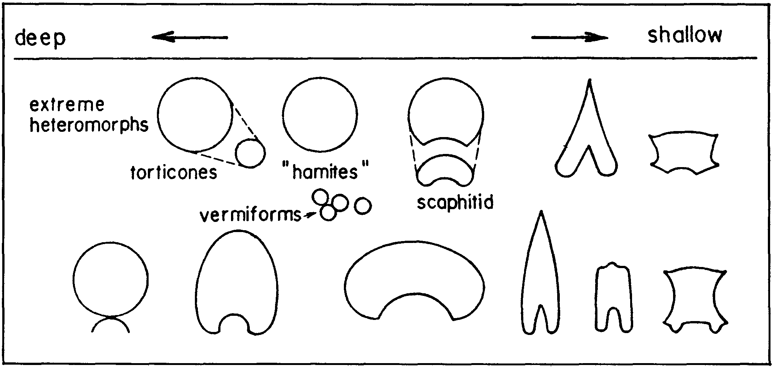
Fig. 1 Strongly generalized depth distribution of ammonoid whorl sections (modified from Ward and Westermann, 1985). The cross-section is not in itself a usefull indicator of habitat.

462 FOSSILI, EVOLUZIONE, AMBIENTE - G.E.G. WESTERMANN

fined to the flanks (lateral spines) whereas ventral spines are rare and found only in evolute forms. This is obviously of some consequence to the predator resistance of the immature organism.

2. Platycones and oxycones — Mobile.
(a) Section ovate, non-plicate. — The fineness ratio (F of Chamberlain, 1981, i.e. shell diameter relative to thickness/width) of most of these involute shells, with or without keel, is lower than that of Nautilus made possible by the fluted internal septal support, see below) resulting in a lower drag-coefficient (Chamberlain & Westermann, 1976; Chamberlain, 1981). This, of course, is indicative of relatively high swimming speed, depending on size etc., but may alternatively, in some cases, suggest resistance against water currents during benthos feeding. There appears to be little reason, however, to restrict "streamlining" to pelagic habitat (e.g. Batt, 1986, 1987). Examples of excellent "streamlining" are Oppeliids, Haploceratids, Phylloceratids etc. Oxyconic Graphoceratids evolved iteratively (or immigrated repeatedly!) in the cyclically shallowing German Basin from the next morphogroup (3) (Bayer & McGhee, 1984). Oxycones were typical for shallow water also in the English Liassic where the rapidly enlarging apertures may have permitted larger prey (Donovan, 1987).
Groups (1) and (2a) comprise the "leiostracans", classically associated with deep-water, oceanic habitat. Typical examples, i.e., Hypophylloceras sp. and Lytoceras liebigi (Oppel), were recently found in a deep-sea drilling core (Hoedemaker, 1987).
(b) Keeled, low sculpture. — More evolute than oxycones; usually with stronger ornament, possibly improving hydrodynamic efficiency (see C), and with ventro-lateral shoulders, reducing it. Examples are Harpoceratids, ribbed Oppeliids.

3. Planulates, depressed "coronates" and some cadicones.
— Sluggish. Most are poorly "streamlined" (for ornament see C). These are the "trachyostracans", i.e. the host of Ammonitina including most Eoderocerataceans, Stephanocerataceans, Perisphinctaceans, Hoplitaceans and Acanthocerataceans. In the Cretaceous, cadicones with conical umbilicus may have lived in cold water, whereas planulates preferred warmer water (Kemper, 1987). Perisphinctaceans often dominated above calcareous substrates.
Typical "coronates" are found among the shallowest offshore habitats. If Batt (1987) is correct in assuming that ontogenetic change in coarseness of ornament reflect habitat change, then many taxa (e.g. Collignoceras) moved up-slope during ontogeny, whereas some pelagics became nekto-benthic.

4. Serpenticones (body chamber - 1 whorl). — ? Pelagic drifters.
The long body chamber (and low W) makes the shell highly unstable, i.e. centres of buoyancy and mass almost coincide (neutral equilibrium). Therefore probably pelagic (but see below). Typical examples are the Dactylioceratids.

5. Highly variable sphaerocones, smooth or ribbed. — Sluggish, ? some pelagic.
High variability in shape and ornament with extreme morphotypes in single populations implies that these features were non-adaptive under the particular ecological

conditions. For example the degree of "streamling" had little effect on feeding, escape, etc. Examples are some Sphaeroceratids, Cardioceratids and Gastroplitids (Kennedy & Cobban, 1978, Text-fig. 9; Callomon, 1985). All have weak or moderate dimorphism, and aptychi are apparently absent. Whereas the highly ornate forms like the Gastrophitids probably occupied some local, low-competition nekto-benthic niche (Batt, 1987), some of the smoother forms may have been planktonic.

6. Orthocones, section mostly ovate. — Sluggish horizontal but rapid vertical (escape) mobility; nekto-benthic (and) or nektonic.
Many shells (Baculites) differ from the rest of the diverse heteromorphs by the well "streamlined" ovate section, implying transverse (horizontal) mobility. The shell was neutrally buoyant (when empty of liquid) and highly stable in subvertical position throughout post-embryonic growth (Ward 1976a; Westermann, 1979). The shell could not be brought into horizontal swimming or floating position since neutral equilibrium would occur only after losing about half of the buoyancy; nor would it have lain immoble on the sea floor by optional fooding (Klinger 1981) because liquid exchange through the siphuncle was too slow (Ward 1982).
Compressed Baculitids could presumably hover sluggishly over the sea floor from which they were feeding, with horizontal mobility comparative to those of the "trachyostracans". They could rapidly escape vertically, and a facultative nektonic habitat with vertical migration is also probable. This habitat is supported by their generally patchy distribution and appearent independence on bottom-water anoxia (Batt, 1987). There is, however, no evidence for lateral mobility in forms with circular cross-section (see Klinger, 1981), such as Sciponoceras. Their distribution in the Western Interior Seaway is more widespread than that of Baculites, independent of bottom-water anoxia, suggesting a pelagic habitat in the upper water column (Batt, pers. commun.). Sciponoceras is found strongly associated with Tetragonitids and Puzosiids (Tanabe, 1979) suggesting a distal neritic habitat.
All orthocones presumably were able to escape and migrate vertically at higher velocity than sculpted planulates; their habitat resembled that of the ancient nautiloid orthocones without counter-balancing deposits, i.e. the primitive Ellemeroceroids and Bactritids. Transverse ornament (? predator protection) was consistently blunt and would not have greatly slowed vertical speed.
Interestingly, both circular and ovate cross-sections are also present in the Jurassic orthocone Paracuariceras (Died, 1981). Whereas the circular form is perfecdy straight (except for the ammonitella) suggesting a planktonic habitat, the compressed forms have curved, sideward opening apertures, indicating some lateral mobility and, hence, a sluggish nekto-benthic habitat.

7. Scaphitoid ancylocones (spheroconic phragmocone, moderate body chamber hook). — Immature pelagic (?), mature pelagic or/and nekto-benthic, with slow horizontal and vertical motility.

The immature shell resembles the possibly pelagic group (5); the strongly modified body chamber made the adult organisms hydrostatically more stable by lowering of the centre of gravity. The upward opening aperture

JURASSIC-CRETACEOUS AMMONOID ECOLOGY
463

suggests feeding from the water-column and the hook of some forms borders on those of true ancylocones, probably preventing benthic feeding. For forms with small hook remaining at or close to the phragmacone (e.g. Hoploscaphites, Discoscaphites, Rhaeboceras), benthic feeding (sluggish nekto-benthic) may, nevertheless, have been optional or the rule, and the upward-opening aperture (and aptychi?) may have protected the animal from benthic predators. Patchy distribution in the Western Interior Seaway also suggests restriction by the conditions of bottom waters, e.g. oxygenation (Batt, 1987). Sometimes small and large body-chamber hooks apparently belonged to corresponding sexual dimorphs, with the microconch having a relatively larger hook than the macroconch, particularly where size difference is great (Tanabe, 1977; Landmann, 1987). The Otoscaphitinae, with large hook, however, are widely distributed, even during periods of bottom water anoxia, indicating pelagic habitat (Batt, 1987). Tanabe (1979) noted that post-mortem drifting must have been minimal according to the abundant preservation of aptychi in body chambers, suggesting a habitat near the sea floor. Landman (1987) stresses the habitat change implied by immature and mature shell change, but he does not specify those habitats.

8. Gyrocones — Sluggish, pelagic or nekto-benthic.
The highly sculpted forms of these open spirals are particularly poorly "streamlined", yet the aperture is in an inclined-forward position so that benthos-feeding would have been possible (nekto-benthic, sluggish): Examples are the large Cretaceous Crioceratids.
Based on faunal association with ancylocones and cosmopolitan distributions, Ward (1976a, b) concluded that the habitat of gyrocones was pelagic. The close phyletic relationship between mid-Cretaceous gyrocones and planulates, on the other hand indicated to Ward (1986) a nekto-benthic habitat for both form-groups. This latter conclusion does not seem to be warranted since habitat change could have occured repeatedly within clades.
Small Spiroceratids from Middle Jurassic mudstones of Germany are sometimes highly variable, from irregular gyroconic to vermiform, suggesting to Died (1978) that their habitat was that of the sessile tube worms. However, a drifting habitat, perhaps in seaweed or floating algae "mats" (see B), seems more reasonable, since passive drifting sets few functional requirements on shell shape. Furthermore, most Spiroceratid species and genera show no exceptionally high variation, and their massed occurrence in the still-water "Hamiten-Ton" suggest a pelagic habitat (Dietl, pers. commun.).

9. Torticones (aperture downward). — Sluggish horizontal and good vertical (escape) mobility: pelagic vertical migrators or nekto-benthic saltators.
The shell combines the high vertical stability and persistently small aperture of a longicone with the compactness and strength of a helicone. The persistent decoupling of any remaining cameral fluid achieved by the laterally positioned siphuncle, reduced the rate of passive flow across the connecting ring and thus stabilized their neutral buoyancy (Klinger, 1981).
A pelagic habitat with diurnal vertical migration is supported by the decoupled siphuncle (Ward, 1979) and by the cosmopolitan distribution of some Turrilites species (Kennedy & Cobban, 1976, Text-fig. 12). The vertical
direction of the uncurved hyponome (Klinger, 1981), together with high stability, would have improved the upward swimming speed. It is now well known that diurnal migration is not achieved by buoyancy change (Ward, 1982). These forms only differ from ancylocones with helical (torticonic) phragmocone in greater vertical mobility; both were much alike in shape and, presumably, habitat before maturity. Alternatively the animal could have been a benthic "hopper". Benthos-feeding would have been facilitated by the downward directed aperture; rapid vertical escape mobility was similar as in the orthocones (6); and horizontal mobility similarly slow. This is supported by the restricted occurrance of Turrilites to proximal basin parts of the Western Interior Seaway and its disappearence during transgression (Batt, 1987). Compared to the orthoconic Baculitids, the shell was more compact and manoeuvrable.
The open low-torticonic Hamitid, Puebloites, of the Western Interior Cretaceous is quite exceptional in coiling geometry and occurrence; it was the first to disappear from the increasingly dysoxic waters during the "Bonarelli anoxic event" (Batt, 1987). Batt may therefore be correct in suggesting that Puebloites was a rare, truely benthic form. It will be interesting to determine if the organism was negatively buoyant, presuming complete shells can be found.
To many researchers (e.g. Lehmann, 1971) the snail-like shell has indicated a snail-like habitat, i.e. benthic vagile or sessile. But this view cannot be sustained and, as in the Baculitids, a horizontal floating orientation by optional flooding of the phragmocone (Klinger 1981) was not possible. Examples are the Turrilitids. Their occurrence in near-shore clastic facies of the Western Interior Seaway during transgressive phases (Batt, 1986), however, could well be due to post-mortem drift.

10. Ancylocones and vermiforms (aperture upwards) — Pelagic, possibly mucus-trap feeders and/or ambush predators.
The megaplanktonic habitat is strongly supported by ubiquitous distribution and facies independence (e.g. Marcinowsky & Wiedmann, 1985).
Nesis (1986) has recently refined the older hypothesis (e.g. Lehmann, 1976) that all or most heteromorphs with up-turned aperture (ancylocones) were planktonic, i.e. they may have been mucus-trap feeders. The analogy is with living gastropods of the tropical ocean, the sessile vermetid Vermetus gigas and especially with the nektonic pteropods Gleba and Corolla. In the former, the pedal gland produces liquid mucus which is played out in long strands by large pedal palps and which traps plankton as well as detritus, followed by ingestion. The Cubulitid pteropods, 20-45 mm long, construct up to 2 m large mucus webs or nets of different shapes which freely hover in the upper waters. Within the holes of the web or net, particles of detritus and phyto- and zooplanktonic organisms get entangled or stick to the mucus. The "harvest" is transported to the animal and swallowed. Nesis argues that the highly abundant (up to 75% of total ammonite fauna) heteromorphs of the Late Cretaceous trapped mainly planktonic foraminifera and calcareous nannoplankton (Coccolithpphorids) ubiquitous at that time.
The only strong argument against this microphagy by mucus trapping is the apparent presence of beak-like jaws, found in a single specimen of the Diplomoceratid Scalarites

FOSSILI, EVOLUZIONE, AMBIENTE - G.E.G. WESTERMANN
464

(Tanabe et al., 1980). According to these authors the jaws were exceptional among ammonites in their ability to bite and cut, strongly indicating predation on larger organisms. If this single find is indeed characteristic of Diplomoceratids (? and other heteromorphs), then a modified form of the mucus-trap model may be feasible, i.e. larger prey was immobilized by "poison" mixed into the mucus, although this is doubted by G.L. Voss (pers. commun.). Perhaps, the alternative hypothesis, rejected by Nesis (1986), has to be retained, i.e. heteromorphs as planktonic ambush predators, "shooting" long tentacles out at prey from an essentially immobile position.
(a) Phragmocone helical (torticonic). — Vertical migrators, slower than torticones: Nostoceratids.
(b) Phragmocone non-helical. — Passive drifters. Diplomoceratids combine "non-streamlining" with "non-compactness". In forms with parallel shafts, e.g. Polyptychoceras, orientation of the aperture changes drastically and repeatedly during growth (Ward 1976a), usually being upward in the adults. This is the termperate-water morphotype (HU) of Batt (1987) from the Western Interior Cretaceous Seaway; whereas his warm-water to Tropical morphotype (OU) has an open coiled, crioceratid phragmocone. Open coiling permits a perfectly circular section, maximizing both buoyancy and strength against imposion. A deep, i.e. mesopelagic, habitat is indeed supported by specific and generic longevity resembling that of the typical "leiostracans" (Ward & Signer, 1983). But the irregular axial shape weakens the shell in buckling and bending stresses, and especially against predators (R. Hewitt, pers. commun.). Most if not all forms seem to have been neutrally buoyant (Ward, 1976a, 1979; Ward & Westermann, 1977) and tended to be widespread even during periods of anoxia in the lower water columns (Batt, 1987).

B) SHELL SIZE, DIMORPHISMS, GROWTH RATE AND LIFE-SPAN
1. Gigantic Ammonitina. — Mostly shallow and warm water.
Stevens (1985a) has argued for a deep-sea habitat by analogy with living giant teuthids, and it may hold true for some Lytoceratids and Phylloceratids; the mature animals were brought onto the shallow shelf by water-mass inversion during transgression, presumably post-mortem. Most very large Ammonitina have been found in rather shallow-water limestone and especially in near-shore sandstone facies (drift ?) of epicontinental seas, whereas closely related or conspecific, smaller forms extended to much deeper habitat (Batt, 1987; Donovan, 1987). There is, however, a taphonomic bias for near-shore occurrence of large over small forms, because, other factors assumed equal, the probability of post-mortem ascent to the surface and, hence, drift varies roughly with size (Chamberlain et al., 1981). Kemper (1987) and Donovan (1987) also found that, in the North German Cretaceous and the English Liassic, respectively, cold-water ammonites are larger than warm-water forms.
2. Small species and stunting. — Semi-cryptic habitats in caves and fissures below the sea-floor have been suggested, unless the examples are death assemblages, sorted and transported from above (Wendt, 1971). Rare, truely stunted species were described by Sturani (1971) from
the "Posidonia alpina Beds" of the Alps, and tentatively explained by inhabiting algal mats. An unspecified relatively deep-water, off-shore habitat has also been suggested for exceptionally small and/or stunted species, similar as for some juveniles (see Hallam, 1987). A stressed environment, such as dysaerobic water is indicated, such as in times of crisis and mass-extinctions when progenesis ("dwarfism") has been implied as a means of phyleric survival (Wiedmann, 1972).
3. Sexual dimorphism. — Well developed dimorphism of the shell, in size and body chamber modification, implies niche partitioning. With respect to ammonites, this would mean nekto-benthic, competitive habitats based on ben-thic food source. The largest dimorphic differences are indeed shown by many groups for which a shallow-water nekto-benthic habitat is inferred on other grounds, e.g. Stephanoceratids, Perisphinctids. On the other hand, pelagic and, particularly, planktonic habitats have the least intra-and interspecific competition. It is, therefore, no coincidence that the oceanic Phylloceratids and Lytoceratids as well as the heteromorphic neritic and oceanic drifters and vertical migrants, have little or no detectable shell dimorphism. That of Sowerbyceras closely resembles present Nautilus (Sarti, 1987). Interestingly, neritic Phylloceratina (e.g. Tragophylloceras) and Lytoceratina (e.g. Pachylytoceras) are clearly dimorphic (Callomon, 1981), and the Scaphitids are intermediate in dimorphism, varying in the different genera from quite strong (e.g. Otoscaphites) to barely detectable (e.g. Pteroscaphites) (Land'man, 1987). In the Stephanocerataceae, the strongly dimorphic Otoitidae evolved into the Sphaeroceratidae, with dimorphism expressed only by modest size difference, perhaps suggesting a change from nekto-benthic to pelagic habitat.
The habitat differences of the sexes implied by strong dimorphism have so far hardly been attended to, besides mentioning that they must have existed (e.g. Lehmann, 1976; Kennedy & Cobban, 1976). In almost all cases, the macroconch was obviously much more mobile, not only because of its larger size but also because of its usually more "streamlined" shape. Good examples are the Jurassic Otoitidae, Graphoceratidae and Oppeliidae, and possibly the Cretaceous Metokoceras and Vascoceratids (Batt, pers. commun.). Seasonal sex segregation is also indicated by highly differing numerical sex ratios within assemblages of the same species at different stratigraphic levels, for example varing from 1:1 to 20:1 in Hoploscaphites nicolleti at a single section in the Western Interior USA (Landman & Waage, 1986). In other genera, sex ratios appear to be quite consistently as high as 100:1, for either sex (Callomon, 1981), indicating distinct habitats or migratory differences between the sexes. Much more work is needed here.
4. Growth rate and life-span. — Since shell growth at the aperture is strongly dependent on buoyancy requirements of the entire organism, growth rates are probably regulated, and certainly limited, by cameral growth. The durations of the two principal parts of cameral growth, septum secretion and emptying, are expected to vary directly with shell size. That is, septal secretion time depends on (absolute) septal thickness which, in turn, tends to remain proportional to whorl (and shell) diameter. Nacreous os-tracum in bivalves also grows at a constant rate (B. Bour-

JURASSIC-CRETACEOUS AMMONOID ECOLOGY
465

goin, pers. commun., 1987). Emptying time increases similarly with diameter because of the surface to volume relationship between siphuncular epithelium (limited by connecting ring diameter) and cameral volume, and because of reduced "pumping" rate under increasing ambient pressure (Ward, 1982). Hence the aperture growth rate is expected to be roughly constant throughout ontogeny, properly compared to (axial or ventral) whorl length, not to the number of septa or angular length; the apertural growth increments tend to remain the same, as does the compound thickness of coeval septa. This linear growth rate has recently been confirmed by experiments on Nautilus (Ward, 1985b). It also follows that macro-conchiate females took longer to mature than their microconchiate males.
For the neritic Ammonitina, several years (2-6) of growth are estimated before the shell fully nature, depending on size, and followed by possibly an equal duration of post-growth existence (Westermann, 1971; Kulicki, 1974; Landman, 1987). The thicker septa and smaller connecting rings of the deep-water forms, especially the oceanic Lytoceratids and Phylloceratids, however, would have severely limited their growth rate, resembling that of Nautilus which takes very approximately 10 years to full maturity (Cochran & Landman, 1984; Saunders, 1984; Ward, 1985b). Thus, the extremely shallow-water Placenticeras, with large siphuncle and thin septa (Hewitt & Westermann, 1976), could probably reach half a meter diameter in a few years, whereas large Lytoceras may have taken half a century to mature.

C) SHELL ORNAMENT (SCULPTURE)
Shell sculpture and its functions have been much argued, but the contradictions may be more artificial than real, with several functions being possible under different or even the same circumstances, e.g. shell protection, camouflage, "streamlining" etc. (see Kennedy & Cobban, 1976; Chamberlain & Westermann, 1976; Ward & Westermann, 1985 etc.). But it is equally possible that the function of a specific sculpture differed taxonomi-cally. Similarly, it is obvious that ontogenetic change of functional sculpture implies habitat or habit change; however, "streamlining" is size-dependent. Corrugated (plicate or rugose) flattish parts of the shell, i.e. the flanks of platycones and oxycones, would also be stronger than smooth ones of the same shell thickness against the point-load by modest predators. Curiously, this seems to be contradicted by the widespread, intraspecific, positive covariation between whorl inflation and ornament rugosity ("(1) Buckman law of co-variation" of Westermann, 1966) also present in goniatites (Swan & Saunders, 1987). Yet, as Ward (1981, 1986) has recently demonstrated, the overall evolution of shell rugosity in Cretaceous ammonites closely paralleled the evolution of marine shell-crushing organisms. The shell rugation of the phragmocone would not improve its strength against ambient water pressure; rather, a smooth conical conch with circular sections is optimally "designed".
Prominent spines are hollow in order to save buoyancy, and floored on the phragmocone to prevent chamber flooding when the spines are damaged. Even relatively fragile spines were certainly an effective mennace to smaller predators, e.g. ammonites. It is also possible that some spines functioned also or even primarily at the peri-
stome (Kennedy & Cobban, 1976), either as mechanical protection of the softparts from predators or perhaps sometimes, as tubes containing sensile organs. Checa (1985) has found body chamber spines which remained open distally. As in productid Brachiopods, these spines may have continued to grow distally even after the peristome had advanced beyond them. The presence of spines on the entire shell could thus be merely a consequense of ontogeny but, more probably, spines had a secondary role in this case, i.e. protection. Another possible function and one that could also have acted simultaneously with others, is camouflage.
Ontogenetic sculpture changes imply changes in protective function, but scaling applies here also. For example, defensive corrugation against a specific predator would become less important with increase in shell size and test thickness, the pattern seen in typically variocostate macroconchs with smooth body chambers. However, stresss by other causes, e.g. impact with the substrate, increases with shell size (Hewitt, pers. commun.). Examples with increased body chamber rugosity are found in many shallow-water Perisphinctids. The peristome is often greatly thickened, usually internally, either on the adult shell only or cyclically (e.g. pseudoconstrictions of Calliphylloceras).
Chamberlain and Westermann (1976) have shown that sculpture does not always increase the drag coefficient (decrease "streamlining"), but potentially increases swimming efficiency of compressed shells, i.e. the golf ball effect. Acceleration at increasing power output of the hyponome would increase suddenly when the laminar flow of the boundary layer becomes turbulent; attaining this critical speed, however, is beyond the reach of all but gigantic (1 m diameter) smooth ectocochliates; and moderate surface roughness (amplitude = 1-2 % of shell diameter) on the frontal area of the shell would optimally lower this critical speed to reasonable levels (25 to 50 cm/sec) for ammonoids of average size (10-20 cm D). Below and above this size and velocity, however, smoother shells would be better streamlined then rough ones.
Kemper and Wiedenroth (1987) have analysed Cretaceous sculpture trends in Tethyan and Boreal ammonoids of northern Germany and found temperature related trends. Warm-water forms tend to be isocostate, constricted, and spinose; cold-water forms on the other hand, variocostate with coarse, non-spinose ribs in the Ancyloceratids and spinous ribs with aberrant body chamber in the Neocomitids.
1. Lirae and dense riblets. — Modest speed increase in larger, well streamlined, shells.
On shells up to 20 cm in diameter (D), ornament with amplitude of only 0.2 % of D would begin to become effective in reducing the drag coefficient at velocities between 25 cm/sec (20 cm D) and 50 cm/sec (10 cm D) (Chamberlain & Westermann 1976, Fig. 12). Thus only relatively large shells (15 cm D) would be moderately advantaged.
2. Moderately coarse ribs (amplitude 1-2% of D) on ? planulates and platicones. — Potentially improved "streamlining".
In "streamlined" planispiral ammonites, optimal speed improvement would have been achieved for ribs with amplitude of 2% of D at about 10 cm D and 20 cm/sec.

FOSSILI, EVOLUZIONE. AMBIENTE - G.E.G. WESTERMANN
466

swimming speed. Experiments are urgently required to test these hypotheses.
3. Coarse ribs, nodes and spines (amplitude 2% of D) — Mostly predator resistance, reduced "streamlining".
In the ancyloconic pelagic drifters, prominent sculpture with long, hollow spines almost certainly served as the protection against some predators, from rather shallow habitat (below wave base) to the aphotic, mesopelagic depth. The functions for spines, heavy nodes, bullae and lateral "horns" as "stabilizers" or "footings" during benthic rest periods have also been proposed (Kennedy & Cobban, 1976; Batt, 1987); but especially the weight function of "heavy" spines (Klinger, 1981) cannot be accepted for reasons of efficiency. Whereas fragile, thin spines occur mainly in the megaplanktonic heteromorphs, heavy nodes, bullae and lateral "horns" are almost exclusive features of nekto-benthic shallow-water, proximal, offshore Ammonitina (Batf, 1987). (Note, however, that occurrences in shoreface sandstone are almost certainly due to post-mortem drift).
4. Constrictions and internal ridges (pseudo-constriction). — True constrictions are well displayed on the shell surface; internal ridges (here called pseudo-constrictions) leave similar impressions on the internal mold, but have no corresponding groove on the shell. The periodic nature and growthline discordance indicate that both types were related to periodic growth interruptions, but periodicity and its causes remain to be investigated. In general, constrictions and pseudo-constrictions occur much more abundantly in warm-water (Tethys) than in cold-water (Boreal) seas (Kemper, 1987). Constrictions are found only in relatively shallow-water, neritic and oceanic habitats, presumably because they weakened the shell wall against implosion by ambient water pressure. This is well shown by the Phylloceratids among which Hokophylloceras with constrictions is also weak in septa and siphuncle, whereas the other Phylloceratids, smooth or with pseudo-constrictions, have all indicators for deep water (Hewitt & Westermann, 1986). Similarly, deep-water Lytoceradds with strong septa and siphundes are also free of constrictions, whereas constrictions are frequent in forms of the epicontinental seas.

D) BODY CHAMBER LENGTH AND APERTURE
The angular length of (spiralic) ammonoid body chambers varies from about 170° in some oxy cones and Lytoceras resembling that of Nautilus, to 450°, in serpen-ticones and some spherocones (Ebel, 1983). Body chamber length is, of course, interdependent with the whorl expansion rate (W) and shell thickness, resembling the proportions of the orthocones (Westermann, 1977; with W substituted by the apical angle). It is the principal determinant of hydrostatic stability (distance between centres of buoyancy and mass) and orientation. Aperture orientation with respect to the substrate in normaly coiled ammonoids, with its implied adaptation to feeding, has recently been calculated for many Carboniferous ammonoids and used as the main criterion between "benthic" (nekto-benthic) and pelagic taxa (Saunders & Shapiro, 1986; Swan & Saunders, 1987). Character associations in recurrent morphotypes, based on sophisticated principal component analysis (Saunders & Swan, 1984), shows that in these goniatites, near-horizontal apertures are
often associated with "streamlined" shells including a hyponomic sinus. These authors therefore suppose that these mobile animals where all nektonic, feeding on pela-gon only; whereas forms with long body chamber, consequent aperture-down orientation, and tending to be ribbed and less streamlined, were "benthic", i.e. sluggish nekto-benthic feeders of the epibenthos. Their calculations of aperture orientations, however, were based on isometry of body chamber coiling, shape and shell thickness, excluding the adult modifications so prevalent at least in the Ammonitina and Ancyloceratina. It is also unknown how far the buccal mass protruded from the aperture during feeding (Donovan, 1987). Although Saunders and Shapiro (1986) rightly rejected Chamberlains's (1981) calculations of swimming speed based on hydrostatic stability and the jet force of the hyponome, swimming ability was nevertheless enhanced by stability, i.e. short body chamber in Oxycones and platycones. Consequently, relatively good swimmers presumably had their hyponomes positioned at about one-third of the height of the facing shell section, so that the thrust was in the direction of the hydrodynamic centre, producing no moment; but they need not have been pelagic. In the poorly "streamlined" and usually ornamented planulates and serpenticones, on the other hand, the instability would have facilitated the required slight rotation around the coiling axes for both functions, benthic feeding with aperture down and sluggish swimming with aperture raised to non-moment level. Examples of one-whorl body chambers with resulting great instability (Saunders & Shapiro, 1986) occur frequently among the shallow-water, sluggish, nekto-benthic Perisphinctids (Ebel, 1983). Some of the longest body chambers occur in the serpenticonic Stephanoceras (Skirroceras) of doubtlessly similar habitat, but significantly, also in the Dactylioceratids for which a planktonic existence has recently been inferred (Tin-tant etal., 1982). One whorl body chambers occur probably also in most adolescent Stephanoceratids, whereas the most common length of fully grown body chambers of Jurassic-Cretaceous planulates, coronates and spherocones was about three-quarters whorls (Westermann, 1971), with extra weight at the aperture in the form of shell thickening or lappets. Poor swimming ability especially of the juveniles, was thus compensated for by improved protection from predators during benthic feeding and high manoeuvrability, perhaps including rotation of the aperture away from the benthic predators.
Perhaps nekto-benthic, macrofagous predators and/or scavengers with serpenticonic shell and consequent long body chamber and retractors, protruded extensively from the body chamber (Jordan, pers. commun., 1981), so that the unstable shell was rotated into aperture-down position and the large buccal mass functioned uninhibited outside of the confines of the narrow body chamber (Donovan, 1987).
The function of the apertural modifications of many Ammonitina microconchs, usually consisting of paired lateral lappets, have been much debated. Protection from predators appears to be the most likely of several possibilities. Large lappets (Fig. 2) would, however, have infringed on any large tentacles such as the webbed tentacles reconstructed by Saul (1979), and a microphagous habit has been proposed (Kennedy & Cobban, 1976). Evidence for the presence of a large hyponome is presented

JURASSIC-CRETACEOUS AMMONOID ECOLOGY
467

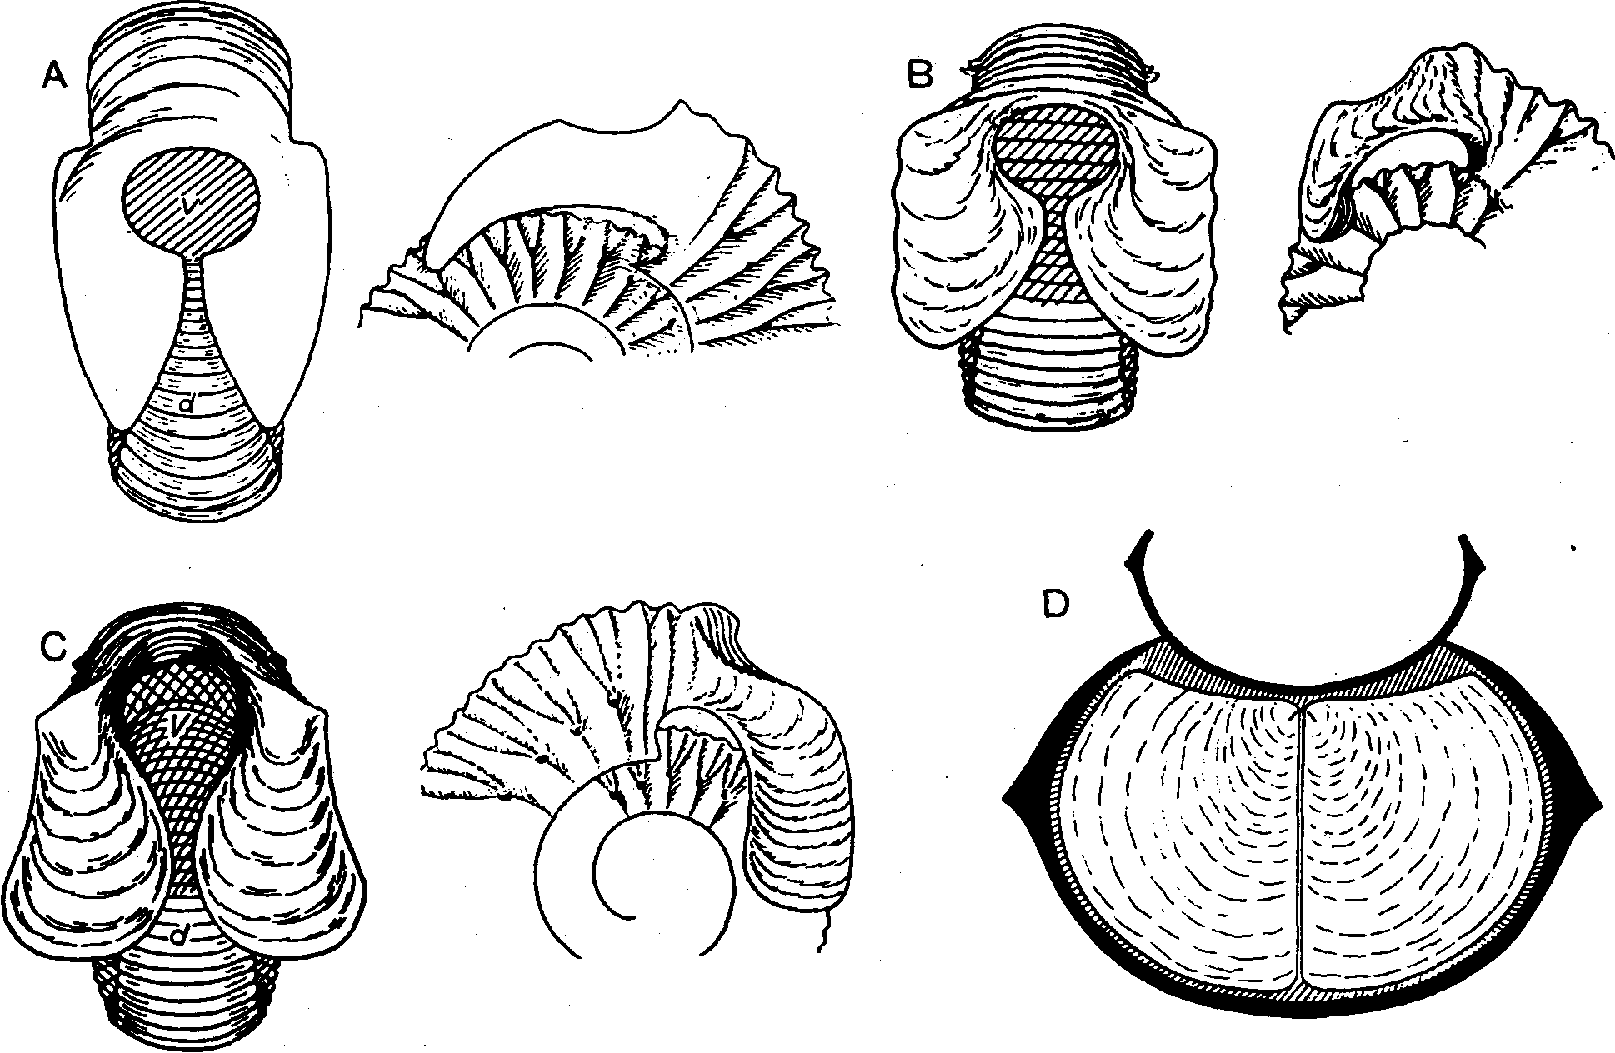
Fig. 2 - Stephanoceratid microconchs with exceptionally large lappets and calcified aptychus. A, Teloceras (NormaHflites) orbignyi Buckman; B, Stefihanocenu (Epalxites) portitor Maubeuge; C, S. (Itinsaites) itinsae McLeam; D, reconstructed position of Pmestnaptychus. (All from Westermann, 1954).

by the subcircular ventral sinus comprised by the large lappets of some Stephanoceratids and Morphoceratids. Morphologic contiguity with other Stephanocerataceans and Perisphinctaceans suggests that a similar hyponome was present at least in their microconchs, the presumed males. In many other ammonite families particularly oxy-cones, the ventral rostrum of both dimorphs suggests, at least in the case of well "streamlined" shells like the Har-poceratids, either a double hyponome (Bidder in Wester-mann, 1971) or a single, long hyponome for which it gave protection (Hengsbach, 1978). This extension would have placed the jet force in the center of the hydrodynamic frontal section, preventing shell rotation, while permitting easy benthic feeding. In still other taxa such as the poorly "streamlined" Sphaeroceratidae and Lytocerati-nae, the aperture in both sexes was "simple" without any sinus or projection, consistent with (but not indicating) the possibility that in these taxa a hyponome was missing.

E) SEPTA, SUTURES AND CONNECTING RINGS
1. Septal sutures. — The degree of sutural complication ("frilling" of the septal margin) has traditionally been taken as a principal indicator for habitat depth, supporting the old hypothesis that the septum braces the phrag-mocone against implosion by ambient water pressure. This remains certainly true for compressed shells (Hewitt & Westermann, 1987a) and appears to be the reason that Ammonitina are in average more compressed than
Goniatitina (Saunders & Swan, 1984). Donovan (1985, 1987) has recently confirmed the validity of this hypothesis empirically on Liassic ammonites of England; as a general trend sutural complication increased with basin depth, and it simplified, even becoming ceratitic, in the Alsatitinae as they entered shallow seas. Yet this correlation is obviously oversimplified. For example, a strong scaling factor applies (Hewitt, 1985), i.e., quite complicated sutures are also present in large, compressed Placen-ticeras which, according to facies and the indices of siphuncular and septal strength, lived extremely shallow (^ 50 m). Furthermore, sutural complication need not be related to shell-wall strength against hydrostatic load (water pressure), but is very effective against point-load (predators). It may even conceivably result from non-adaptive allometry of the juvenile septum due to an initial septum size and a simple genetic growth program (Hewitt, 1975;, Hewitt & Westermann, 1987a) or, through phylogeny, the genotype of deep-water ancestors. The highly fluted septal sutures also produced a flexible brace for the shell wall, particularly for the flattened flanks in compressed shells, distributing and thus reducing the local stresses caused by point-load. This contrasts with the non-fluted septa of nautiloids or goniatitic septa where the highest stress in the outher shell develops above the septa with most nearly normal angle to the shell wall (Hewitt & Westermann, 1986). A fine example of elastic shell-wall support is provided by mosasaur bites on the oxycone Placenticeras where the shell is punctured

FOSSILI, EVOLUZIONE, AMBIENTE - G.E.G. WESTERMANN
468

but not necessarily crushed, so that only single camerae would lose buoyancy (Hewitt & Westermann, in preparation).
The conclusion of deep-water habitat from sutural complication has therefore to be accompanied by consistently narrow sutural spacing, so that inter-sutural and intra-sutural spacing are matched (Westermann, 1975; Ward & Westermann, 1985). This is particularly required for oxycones and platycones where sutural support was required for wall support against hydrostatic pressure ("Westermann model" of Hewitt & Westermann, 1986, 1987a).
Both the degrees of sutural complication and septal approximation also contribute to the "sutural reinforcement index" (SRI) of Batt (1986, Fig. 11), i.e. the ratio of maximal saddle height against corresponding whorl circumference from venter to umbilical seam (dorsum in open-coiled forms). Since this parameter depends on the whorl sections (Hewitt, 1985), the index varying inversely with whorl height, and size, Batt (1987) correctly restricted its use to homeomorphs. Thus, among oxycones, the shallow-water Placenticeras stands out by an exceptionally low SRI, whereas sutural complication resembles that of most oxycones. Similarly, the heavily nodose M.am-mites, with high SRI occurs in the deeper basin center of the Western Interior Seaway, whereas all similar forms with low SRI are restricted to shallow water (Batt, 1987). This indicates that the amplitude of the primary septal flutes varies with shell strength, somewhat independently of the higher-order fluting. Henderson (1984) and Hewitt and Westermann (1987a) have, however, shown that most round-whorled, shallow-water Ammonitina probably did not require septal support of the shell-wall against implosion by ambient water pressure at their estimated habitat depth.
Support for the strength increase of compressed whorls by sutural complexity has recently been provided by Ward (1980). He confirmed the supposition (Westermann, 1966) that, as a rule, complexity increases with degree of shell compression, compensating for diminished wall strength caused by the flattening of the flanks in platycones and oxycones; i.e. compressive membrane stress by ambient pressure increasing with the curvature radius. Buckling phenomena cause even stronger stresses in flattish parts of the shell (Hewitt, pers. commun.). On the other hand, the phyletically grossly simplified "ceratitic" sutures are reliable indicators for life in shallow epicontinental seas.
2. Septa. — Turning now to the central parts of the septum, a new bathymetric indicator is the Septal Flute Strength (Hewitt & Westermann, 1987a). This index is simply the ratio of maximum septal thickness near whorl centre to the minimum whorl radius (inner height or width). It assumes that membrane stresses in certain parts of the principle flutes are the same as in a cylinder with a similar shell thickness and curvature radius. The radius approximates to half of the minimum whorl diameter, i.e. width or inner height. This index is therefore similar to the Septal Strength Index for the simple-concave septa of nautiloids (Westermann, 1973), but lacks theoretical proof at this time. As shown in Figure 3, this parameter correlates highly with the Siphuncle Strength Index (100 x wall thickness/inner radius of connecting ring), at the same time confirming the usefullness of both parameters.
The only obvious exceptions are found in the typically compressed and deep-water, non-constricted Phyllocer-atids (Phylloceras, Calliphylloceras, Ptychophylhceras). Here the septa are much thicker than predicted from the water load conducted through the body on the surface of the last septum, i.e. the septum functioned here mainly as a fluted strut bracing the flanks of the shell wall against each other. In contrast, the genus Hokophylloceras with true (external) constrictions, which weaken the shell against ambient water pressure, has much lower and matching strength indices for both septum and connecting rings. Facies analysis by B. Geczy (pers. comm., 1987) in the Jurassic of Hungary, has confirmed that Hokophylloceras occupied shallower regions than the other genera. Its occurrence in near-shore bivalve assemblages (Kim-shieshvili, 1987 and pers. commun.), however, appears to be owing to post-mortem drift.
The maximum depth ranges of mature Nautilus, Spirula, and various Sepia species consistently amount to between two-thirds and three-quarters of the depth limit defined by shell implosion. Immature Nautilus implodes at about 400 to 600 m water depth (Hewitt & Westermann, 1987c) and the habitat depth is still uncertain. The mutually reinforcing septal and siphuncular strength indices permit estimation of the habitat depth of the ammonites (Fig. 3). Nekto-benthic Ammonitina ranged from the proximal sublittoral (Placenticeras and "neoceratites") to the deepest distal sublittoral of the continental shelf {Canadoceras and Pachydiscus), with the large host somewhere between these extremes, i.e. they descended to about 100-250 m depth; some pelagic, typically heteromorph Ancyloceratina (Diplomoceratidae) lived rather deep, to about 300-500 m; most (unconstricted) Phyllocer-atina, Tetragonitadae and oceanic Lytoceras lived at least as deep as Nautilus (to 500-600 m) and probably maximally to 800 m; but Hokophylhceras and many epicontinental Lytoceratines, with constrictions, had depth ranges similar to those of the deeper Ammonitina. Like Nautilus, vertical diurnal migrants may, of course, have ascended irrespective of shell strength, since there are no structural limits toward lower pressure. In fact, at least all growing deep-water ammonoids, like nautiloids, probably needed to be temporarily (diurnal migration) above 240 m depth, the critical ambient pressure for the "osmotic pump" (Ward, 1982; Ward & Westermann, 1985). Adult ammonoids could possibly make the connecting rings impermeable, eliminating the necessity for vertical migration but thus also becoming incapable of changing and adjusting their buoyancy.
3. Connecting rings. — There have been several recent objections to the Siphuncle Strength Index (Fig. 4) and to the Septal Strength Index as originally defined for "simple concave" nautiloid septa. Objections to the former index have recently been discussed at some length (Ward & Westermann, 1985). Most are overcome by application of an ontogenetic scaling factor and by making sure that the measured connecting rings are complete. High siphuncle strength (thick wall and small radius of connecting rings) is a trade-off against the rate of liquid exchange (low permeability and small surface area) and both functions are by no means exclusive: shallow-water ammonoids could change buoyancy more rapidly and, presumably, grow faster than deep-water forms. Objections to the Septal Strength Index have been overcome

JURASSIC-CRETACEOUS AMMONOID ECOLOGY
469

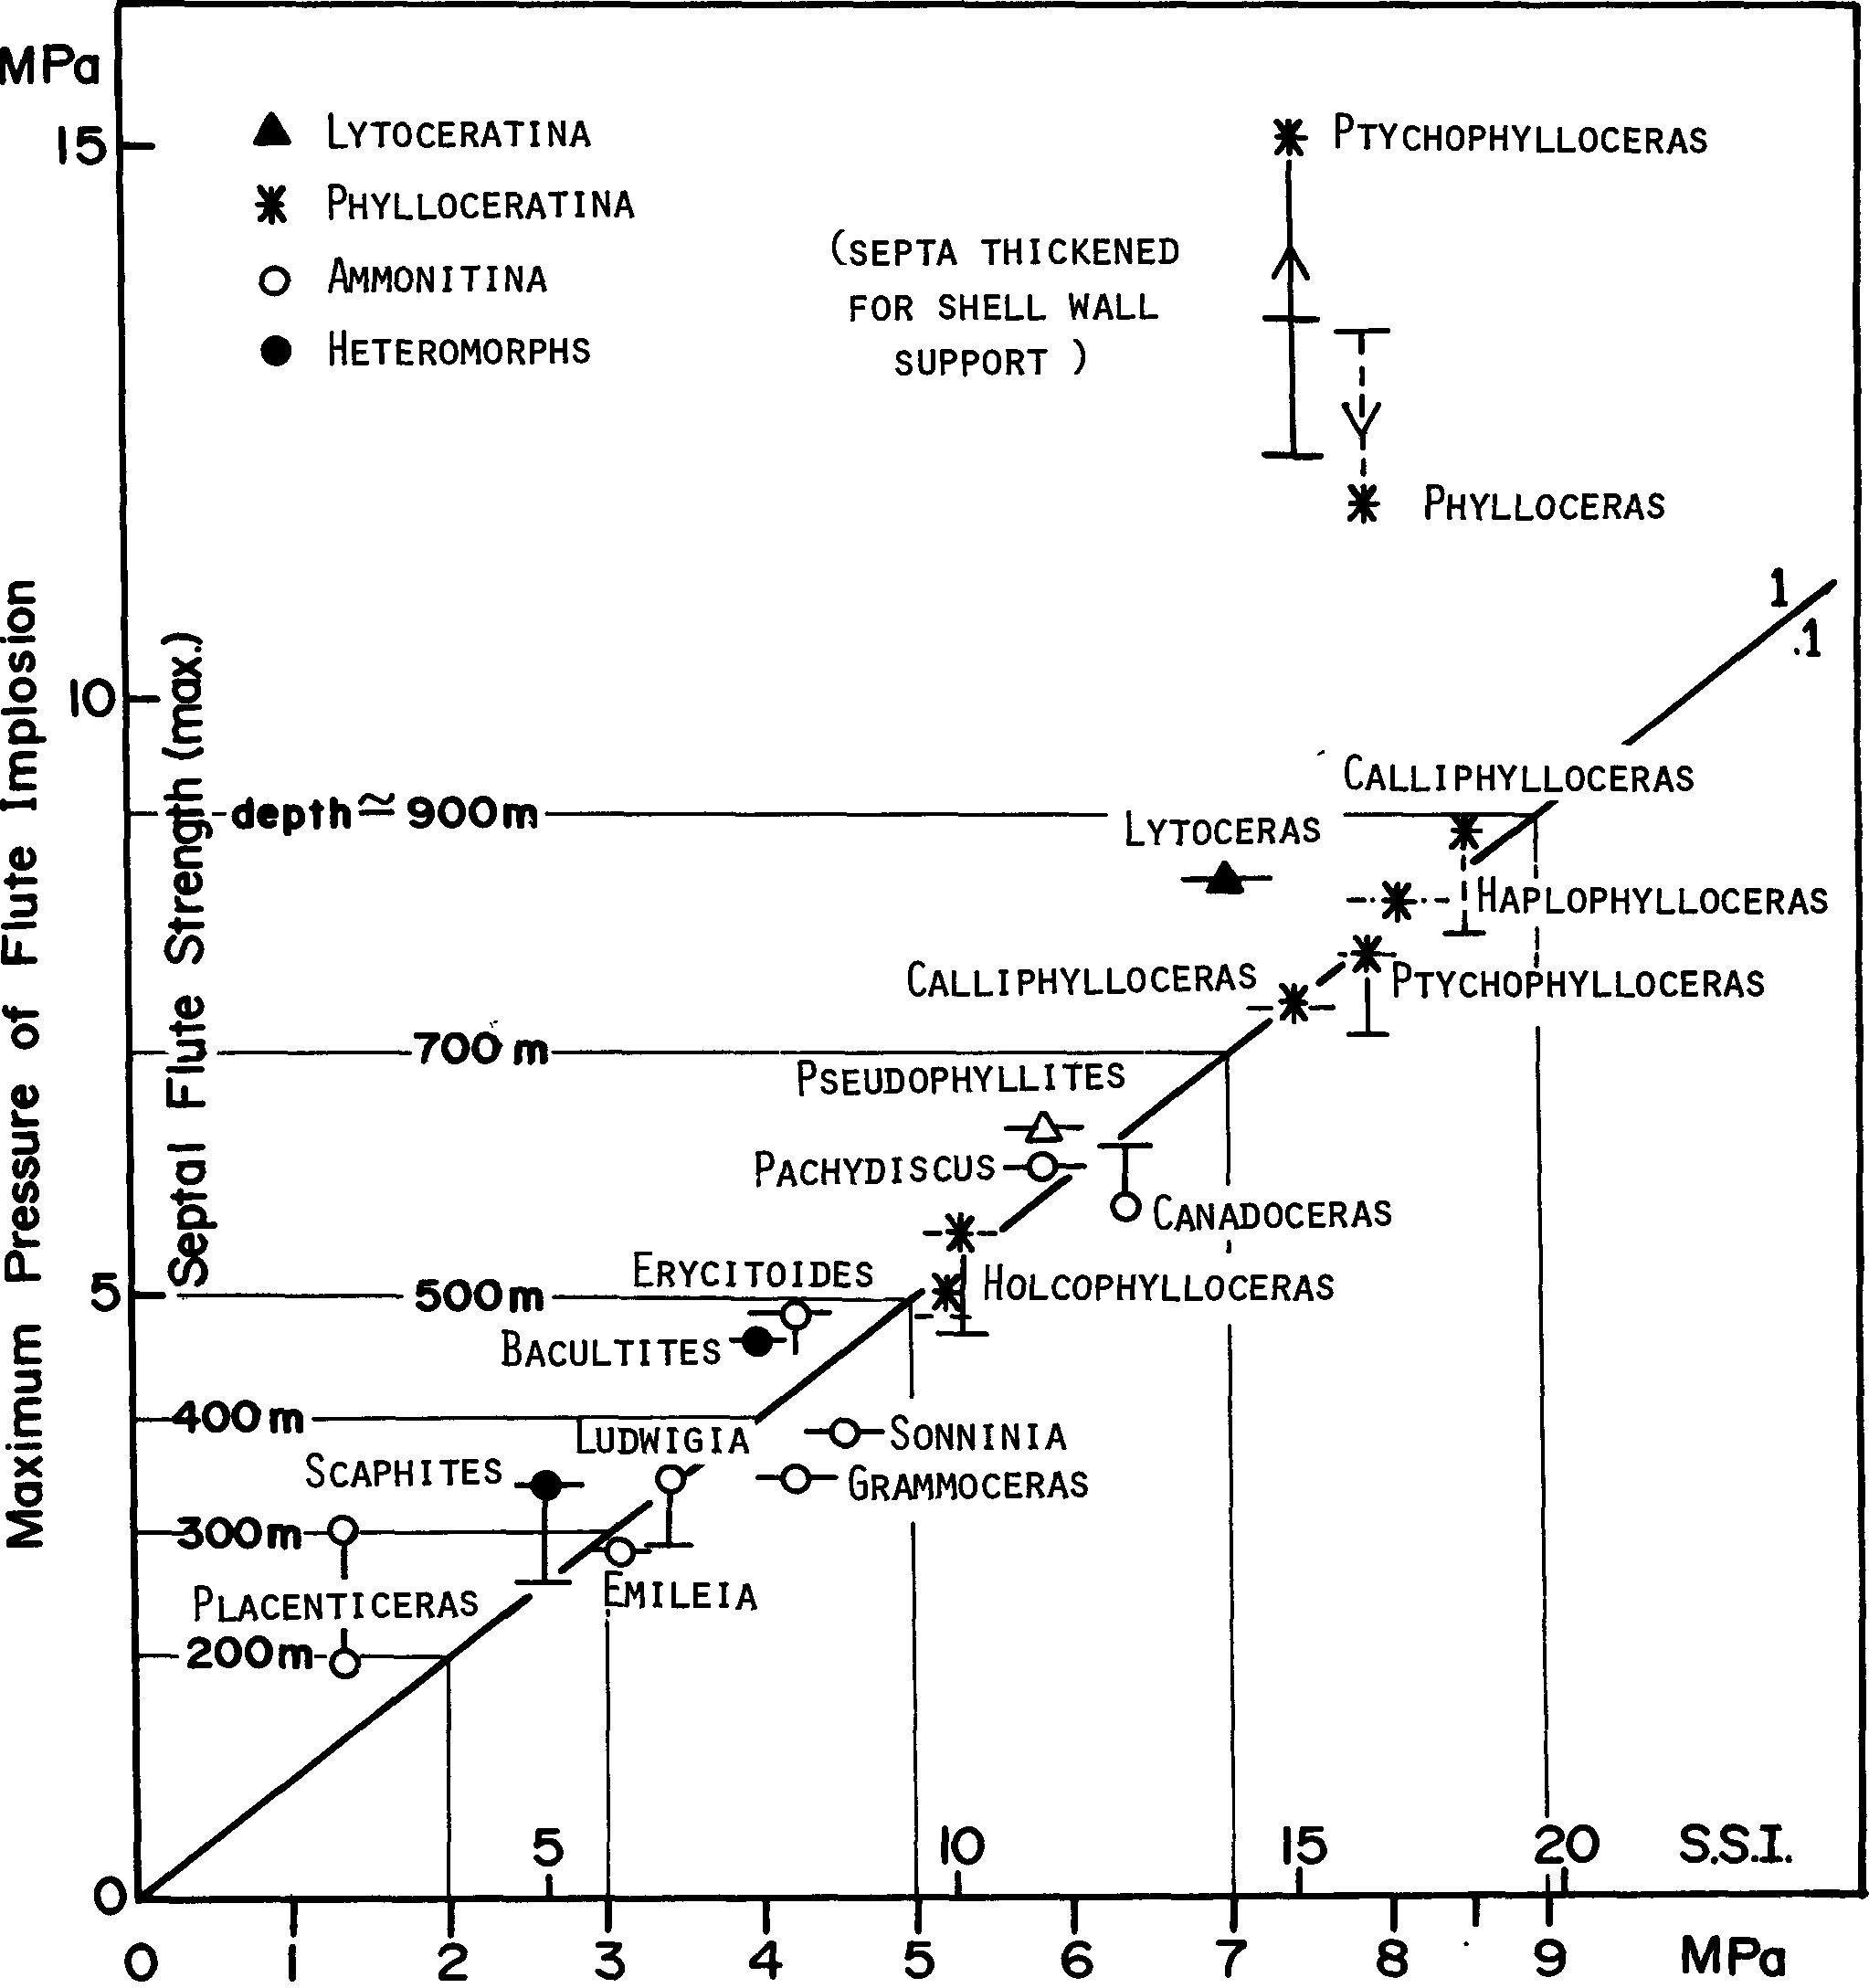
The Siphuncle Strength Index and its Rupture Pressure
Fig. 3 - Correlation of Siphuncle Strength Index with Septal Flute Strength (the former also converted to hydrostatic pressure, MPa). There is a close correlation, except for the deep-water Phylloceratids which secreted exceptionally thick septa functioning as struts to support the flattish flanks of these platyconic shells. (Modified from Hewitt & Westermann, 1987a; higher S.S.I, values re-calculated according to thick-walled cylinder equation given in Hewitt and Westermann (1986, 1987c)).

by recent experiments on Nautilus shells (Hewitt & Westermann, 1987b) and live Nautilus (Ward, pers. commun., 1987).

F) BUCCAL MASS
1. Aptychi. — The modern consensus is that most anaptychi and aptychi were functional "jaws"; all were

homologous and belonged to the buccal mass which in some cases has been shown to also contain a radula similar to that of the predaceous Teuthoids (Lehmann 1971, 1981). But most ammonite "jaws" could neither bite nor cut. Exceptions are the planulate Collignoceratid Reesidites (Tanabe, 1987), some Lytoceratids (Lehmann etui., 1980), and the ancyloconic heteromorph Scalarites

FOSSILI, EVOLUZIONE, AMBIENTE - G.E.G. WESTERMANN
470

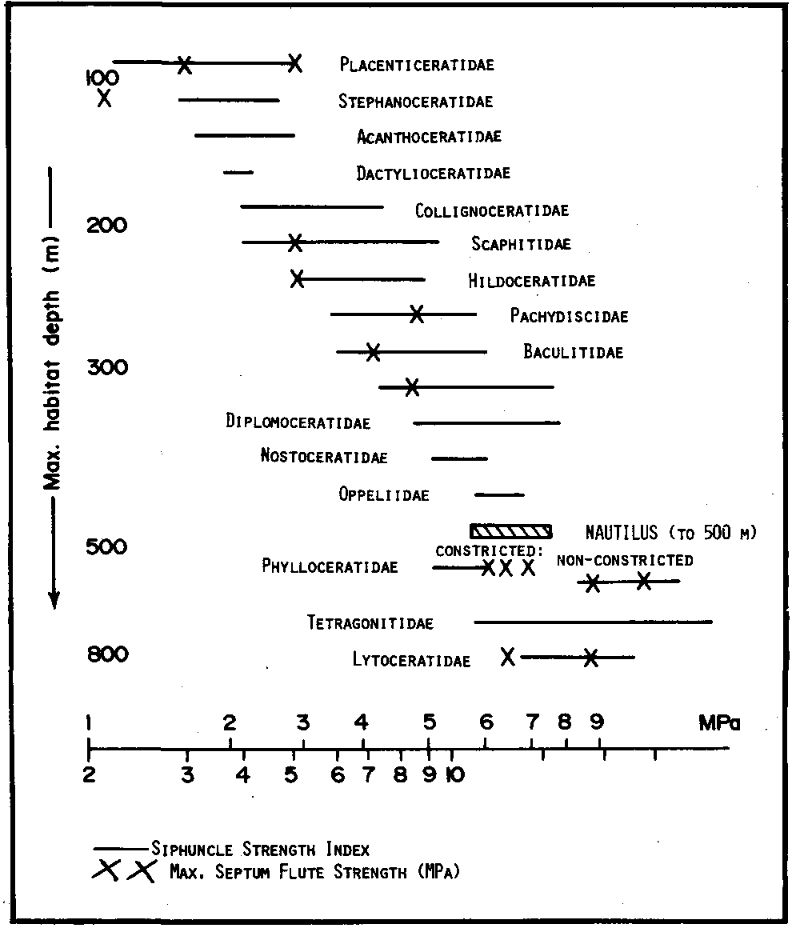
15 20 25 S&I.
Fig. 4 - The Siphuncle Strength Index (S.S.I.) for Jurassic-Cretaceous ammonoids, according to Westermann (1971), Tanabe (1979), Ward & Signer (1983) and Hewitt & Westermann (1987). Note that parts of the ranges represent ontogenies. Families arranged in order of increasing S.S.I., and Nautilus is included for comparison. The Septum Flute Strength (max.) is indicated by crosses (see Fig. 3). The rough estimates for lower habitat limits are indicated at the left margin.
(Tanabe et al., 1981) which have well developed chitino-phosphatic or calcified beaks. Lehmann (1971) interpreted the larger and heavier developments of aptychi as "showels" or platform-like "plows" stirring up the water-sediment interface for microphagous feeding on foraminifers and ostracods. The presence of a coleoid-type radula in the same genus however, does not support microphagy (see below). The protective lid-function of the very thick aptychi, e.g. Laevaptychus, seemingly fitting into the aperture, and perhaps also of the less heavy Lamellaptychus of Oppeliids and (?) the Phylloceratid Ptychophylloceras (Bachmayer, 1963; a fluke of preservation?) remains acceptable (Kennedy & Cobban, 1976). Dzik (1981) suggested that both the lid and jaw functions were feasible in some taxa, whereas Bandel & Boletzky deny that possibility (pers. commun., 1987).
Bandel (1987) believes that aptychi and anaptychi were true operculi sensu Schindewolf (1957) and not homologous to the lower cephalopod jaw. He describes all three elements from a single specimen of the Carboniferous Goniatite Eoasianites. The repeatedly found juxtaposition of true aptychi, e.g., Praestriaptychus of Stephanoceratids (Westermann, 1954; Lehmann, 1972), however, makes his position untenable at least for Jurassic-Cretaceous ammonites (Lehmann, 1987).
Morton (1981) has reexamined some of the supposedly very few known ammonites with alleged apertural position of aptychi and found the lid-function hypothesis untenable. The lid-position of Laevaptychus and Lamellaptychus is supposedly the freak result of rare vertical embedding of the shells, which were also incomplete with

missing aperture. He also noted that in some cases the aptychus is consistently preserved at around 50° behind the aperture, i.e. one-fifth of body-chamber length, and in "normal" orientations, with the hinge forming an acute angle with the venter of the shell. The Lamellaptychus of a larger sample of Oppeliids from the Solnhofen Limestone of Germany, show a second consistent position, at the aperture with oblique orientation to the apertural plane (Schindewolf, 1958, Plate 7).
In a recent paper, Morton & Nixon (1987) propose new functions for calcified aptychi: (1) they gave rigidity to the outside of the buccal mass increasing its ability to squeeze large quantities of water through a filter for microphagous feeding (but see radula, below). The envisaged contraction between the upper and lower "jaws", however, would hardly require a stiff lower plate, since circular musculature would work without them. As the authors notice, furthermore, aptychus growth is isometric, not negatively allometric as that of buccal masses. (2) "Heavy" aptychi could be brought forward during feeding to change the centre of gravity of the organism and, hence, the orientation of the aperture. But the thick aptychi were highly cancellous (Schindewolf, 1958). (3) Thick aptychi may also have protected the buccal mass during benthic foraging, presumably functioning like a semi-closed lid (operculum).
The calcified Praestriaptychus of the Stephanoceratid microconchs (Fig. 2 D) probably did not function as lid (operculum) nor as a "shovel" or "plow", since the mature aperture was largely occluded by the lappets. These like other aptychi were also disproportionately large and stiff, compared to the thin chitinous upper jaws (Lehmann, 1972), and for the sole function as lower jaws in organisms which were supposedly microphagous (see above).
A new, principal or supplementary function is here tentatively proposed for the thinly calcified, usually shovel-shaped aptychi (Fig. 5). Perhaps they could also act as locomotors, i.e. a reciprocating folding board or hinged louvre fan producing a strong water current for the hypo-nome. This would substitute for, or greatly increase, a Nautilus-like pumping by the cephalic mass (see introduction) in the much longer and narrower ammonoid body chamber. Both valves of the hinged aptychus, held open below the buccal mass, would act as a stiff plate within the anterior part of the mantle cavity (in front of the gills) during the powerstroke. They would partially fold during the compensation-stroke reducing the frontal section and letting water re-enter into the cavity. Rapid reciprocation would produce the water current which is lead into the hyponome. Aptychus flapping may have been not only angular around its dorsal "hinge" in the buccal mass, but also by for-and backward stroke together with the entire or lower buccal mass, thus amplifying Naaft'/w-like pumping. Since the mantle cavity was closed in the rear, the power-stroke was backwards. (In a forward power-stroke, re-entry of new liquid would have to be simultaneous and under pressure as in a 2-stroke engine). The power-stroke was accomplished by the long retractor muscle attached, anteriorly, to the aptychus and/or the (? lower) cephalic cartilage and, posteriorly, to the dorsal end of the body chamber, somewhat similar as reconstructed without aptychi by Kennedy & Cobban (1975, Text-fig. 5c, d).
The proposed pumping action of thinly calcified apty-

JURASSIC-CRETACEOUS AMMONQID ECOLOGY 471
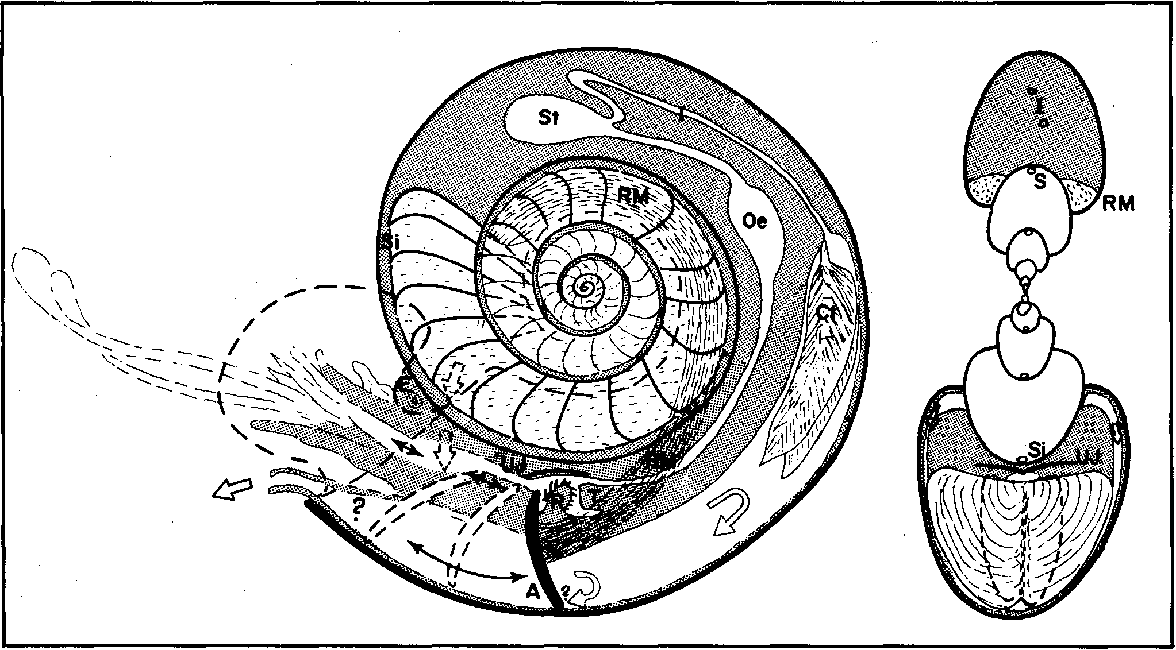
Fig. 5 - Tentative reconstruction of an ammonitine microconch (Stephanoceras in Fig. 2B), with aptychus (Praestriaptychus) as locomotor at end of powerstroke. In the sagittal section clashes show project parts of shell and animal, and recovery-stroke position of the "reciprocating louvre fan" (aptychus). Hollow arrows indicate water currents (problematic between aptychus and hyponome), and solid arrows the proposed motions of aptychus and buccal mass. Tentacles reconstructed with eight short arms between the quasi-occluding lateral lappets of the shell aperture (Fig. 2B) and two long catching arms. A - aptychus, dashed for recovery stroke (in closed position); Ct - ctenidia; E - eye; Oe - oesophagus; RM - paired retractor muscle; Si - siphuncle; St - stomach (Organ reconstruction modified after Lehmann, 1976).

chi appears to be compatible with their alternate function as lower jaw, but less so with that of a lid. This loco-motor hypothesis is supported by (1) the general good match of the lateral and ventral outline of the aptychi with the corresponding parts of the whorl section, i.e. the mantle cavity; (2) the noncalcified nature and much smaller size of the corresponding upper jaws, contrasting with the condition in living cephalopods where the lower jaw is the smaller one (Lehmann, 1972; Morton & Nixon, 1987); (3) the presense of an elastic "hinge" between the two aptychid plates; (4) the absence of wear on the supposed cutting edge; (5) the presence of these aptychi even when the aperture is partially occluded; (6) the "normal" burial positions near the venter c. 50° behind the aperture; (7) their sometric growth relative to shell and, presumable, whorl size (Morton & Nixon, 1987); and (8) the slender, elongated shape of the am-monoid body chamber and, presumably, the body cavity, so that Nautilus-Wie rocking of the cephalic mass for jet action would be highly inefficient. This hypothesis may thus solve the puzzle of the much greater length of the ammonite body chamber compared to that of Nautilus.
The calcitic layers of Laevaptychus, Spinaptychus and Lamellaptychus are unnecessarily thick to have functioned as lower jaws (against uncalcified upper jaws) and/or locomotory fans. They probably served mainly as lids (operculi) protecting against predators. This is supported by the cancellous texture and, particularly, by the punctate nature of the outer, convex shell growth surface in Spinaptychus (Fischer & Fay, 1953). It suggests the presence of cells with chemo-repellants rather than

a sensory function (Hewitt, pers. commun., 1987).
Large, conical chitinous anaptychi, with small calcified beaks (rhyncholite and conchorynch) are developed in Lytoceratina, particularly in the platyconic Tetragonitids, and in Desmoceratid Ammonitina (Lehmann et al., 1980; Tanabe, 1983; Tanabe & Fukuda, 1983), clearly resembling Nautilus jaws and indicating similar predatory habits. At least in some Lytoceras, however, the circular base of the shallow cones fits perfectly into the circular whorls.
2. Radulae. — Few complete radulae are known, i.e. in the Lower Jurassic Ammonitina Eleganticeras, Hildoceras and Dactylioceras, but frequent fragments indicate their ubiquity (Lehmann, 1981). This clearly implies a close ecological resemblance of these ammonoids to the predi-tory coleoids and to ancestral orthocerid nautiloids with similar radulae (Mehl, 1984).
Little is known and nothing published about the relationship between radulae and the different types of prey in the living cephalopods, according to Dr. G.L. Voss, (pers. commun., 1987). This specialist on the living coleoids, however, believes that his own unpublished data show a good general correspondence between radula type and feeding habit. Thus, the highly efficient predators among the squids, i.e. Loligonids and Omnastrephids, have all very similar, strongly developed, sharp radular teeth for tearing and rasping, which are essentially invariant within the families; both families prey on fish, crustaceans, and other squid. These radulae resemble those known from the Ammonitina and Goniatitina (see Lehmann, 1976, Fig. 72). In contrast, in the bathypelag-

472 FOSSIL}, EVOLUZIONE, AMBIENTE - G E G WESTERMANN

ic cirrates living on a diet of small, soft-bodied prey, the radulae have been lost or are vestigial, with high variance. Similarly, the abyssal octopod Graneledone has either vestigial or highly variable radular teeth; large prey for them is missing or rare. Dr. Voss concludes that phyletic loss or reduction of radulae is due to lack of selection pressure in feeding, and implies that this trend occurs whenever these conditions occur.

G) INJURIES, ABNORMALITIES AND HABITAT
Healed injuries, some perhaps caused by collision with hard substrate in shallow water, are especially frequent in the shallow-water Stephanoceratids (Bayer, 1970); pre-dation was probably a more general cause. In Maastrich-tian Scaphitids, sublethal injuries tend to be most frequent in the largest macroconchs of the most coarsely ornate Hoploscaphites, and up to 20% of the population may be affected (Landman & Waage, 1986). Small, almost smooth microconches are least effected. These data suggest that the most ornate and largest forms lived in the shallowest water and/or closest to the substrate. Mosasaur bites frequently killed the shallow-neritic Placenticeras and are also known from the probably deeper-water Anapachydiscus (Saul, 1979). Most injuries seem to have occured in shallow habitat, mainly by benthic and a few nektonic predators, e.g. belmnites and some ammonites. In the ocean, large predators, particularly crocodiles and mosasaurs may have displaced pelagic ammonites into deeper epipelagic and the mesopelagic waters. In general, however, Mesozoic predators of ammonoids were mainly benthic, in the Cretaceous forcing nekto-benthic taxa increasingly into the pelagon (Nesis, 1987). But inverse evolutionary trends, from planktonic to nekto-benthic, are also suggested (Wiedmann, 1969).
Abnormal developments, especially asymmetry of the septal suture and position of the siphuncle, occur mostly in shallow-water ammonites, presumably because mechanical requirements related to ambient water pressure were less rigid. But the causes and ecologic significance of abnormalities remain unknown (Hengsbach, 1979, 1986).

THE PRINCIPAL AMMONOID HABITATS (Fig. 6-8)
Definitions: Horizontal mobility of ammonoids varied considerably as indicated by relative "streamlining". Since the propulsive forces can only be surmized (Chamberlain, 1981; Donovan, 1987; and see above) a two-fold classification of relative mobility is based on a rough estimate of the relative hydrodynamic efficiency of the shell, rather than on assumed velocity.
Nektonic/Nekto-benthic I (sluggish): hydrodynamic efficiency less than that of Nautilus (drag coefficient 0.5; 25-40 cm/sec) (Ward, pers. commun).
Nektonic/Nekto-benthic II (mobile): Hydrodynamic efficiency as great or greater than that of Nautilus.

A) OCEANIC

1. Shallow, photic zone ((50) 100-250 m) — also neritic.
(a) Plankton: Probably the "pseudolarvae" of Lytoceratina, Phylloceratina and of some heteromorph Ancyloceratina. These minute but fully developed hatchlings (Bandel et al., 1982) with gas-filled protoconch were neutrally buoyant, and twice the size in Tetragonitid Lytocera-

tina than in the Ammonitina (Tanabe & Ohtsuka, 1985). The planktonic stage may have lasted only several days or up to about one month, consistant with passive drifting of neritic ammonites across narrow, deep oceans up to a few hundred kilometers in width (Cariou et al., 1985; Kutek & Wierzbowski, 1986). During this time the animal secreted at least several septa (Bandel, 1982) and possibly as much as two whorls, to the end of the juvenile growth stage at 3-4 mm shell diameter (Landman, 1987), developed small retractor muscles for locomotion (Doguzhaeva, 1969; Doguzhaeva & Mutvei, 1986; Bandel, 1982) and the jaw apparatus, including a calcified aptychus (Kulicki & Wierzbowski, 1983). A discrete juvenile stage is known from different neritic ammonoid taxa (Westermann, 1956; Landman, 1987).
Maximum residence time in the plankton can be roughly estimated from the growth rate of the juvenile stage, i.e. the second and third whorls. As outlined by chapter B4, we assume a linear axial growth rate throughout ontogeny except for the final deceleration. The time intervals are thus proportional to axial length; i.e. the 2nd and 3rd whorls compared to the entire shell. If an "average" ammonitic shell with 8 whorls and 100 mm diameter (W = 2.0) has approximately 520 mm venter length, then
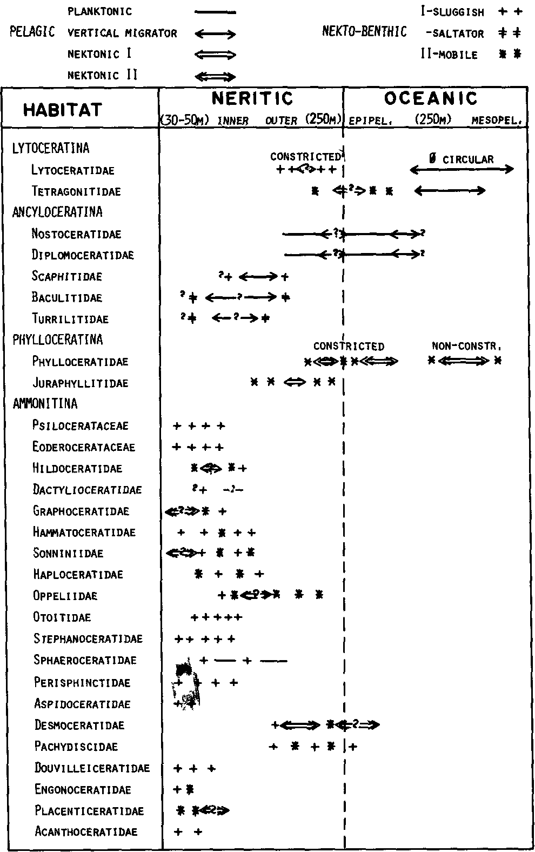
Fig. 6 - The possible habitats of Jutassic-Cretaceous ammonoids Mixed symbols reflect diversity of habitat within families and between sexual dimorphs (NOT habitat change with depth)

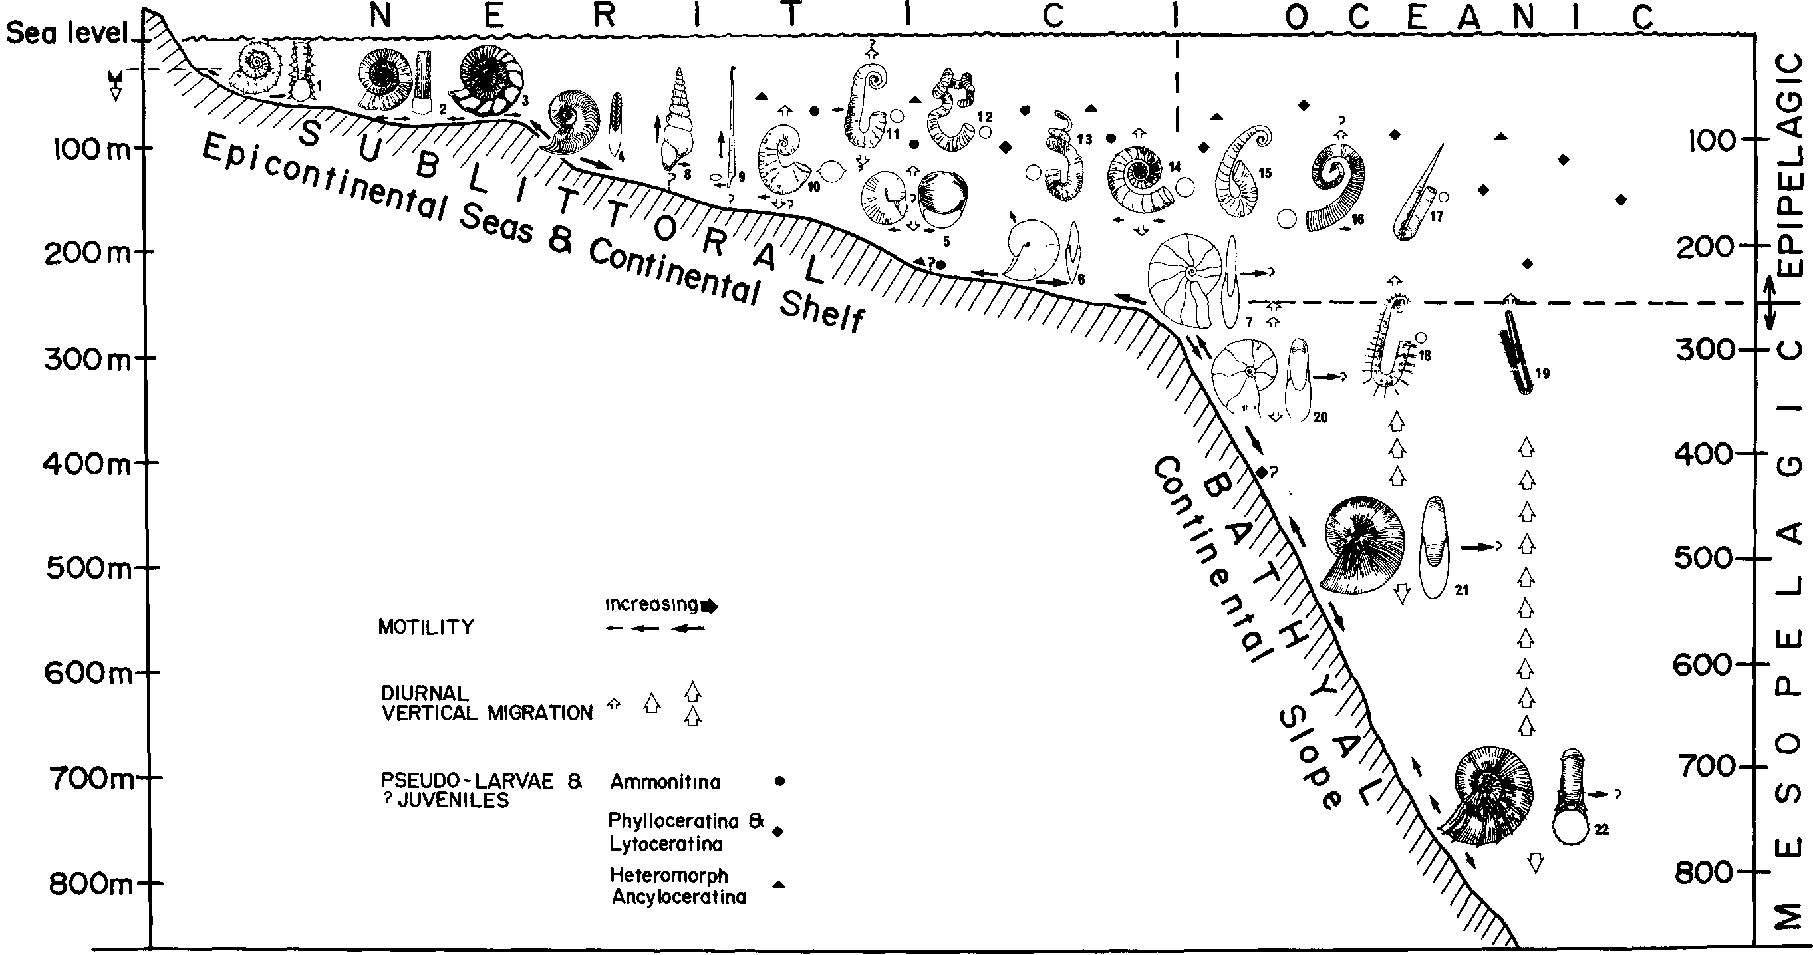
Fig. 7 - Stylized panorama of Jurassic-Cretaceous ammonoid habitats. Note that only an arbitrary selection of morphotypes and of their habitats can be illustrated and that near-shore habitats excluded onites. (See Fig. 6 for ranges and diversity within taxa). Note that the vertical arrows for migration do not imply vertical locomotion.
AMMONITINA: 1 — Peltoceras, Aspidoceratidae; 2 — Arietites, titidae; 3 — Perisphinctes, Perisphinctidae; 4 — Harpoceras, Hildoceratidae; 5 — Sphaeroceras, Sphaeroceratidae; 6 — Oxycerites, Oppeliidae; 7 — Barremttes, Desmoceratidae.
ANCYLOCERATINA: Tumlttes, Turrilitidae; 9 — Baculites, Baculitidae; 10 — Scaphites, Scaphitidae; 11 — Ancyloceras, Ancyloceratidae; 12 — Nipponites, Turrilitidae, 13 — Didymoceras; 14 — Cnoceratites, Ancyloceratidae; 15 - Labeceras, ? Labeceratidae; 16 — Glyptoxoceras, Turrilitidae; 17 — Hamulina, Ptychoceratidae, 18 — Amsoceras, Anisoceratidae; 19 — Pseudoxybeloceras, Turrilitidae.
PHYLLOCERATINA: 20 — ophylloceras, Phylloceratidae; 21 — Phylhceras, Phylloceratidae.
LYTOCERATINA: 22 — Lytoceras, Lytoceratidae.
FOSSILI, EVOLUZIONE, AMBIENTE - G.E.G. WESTERMANN
474

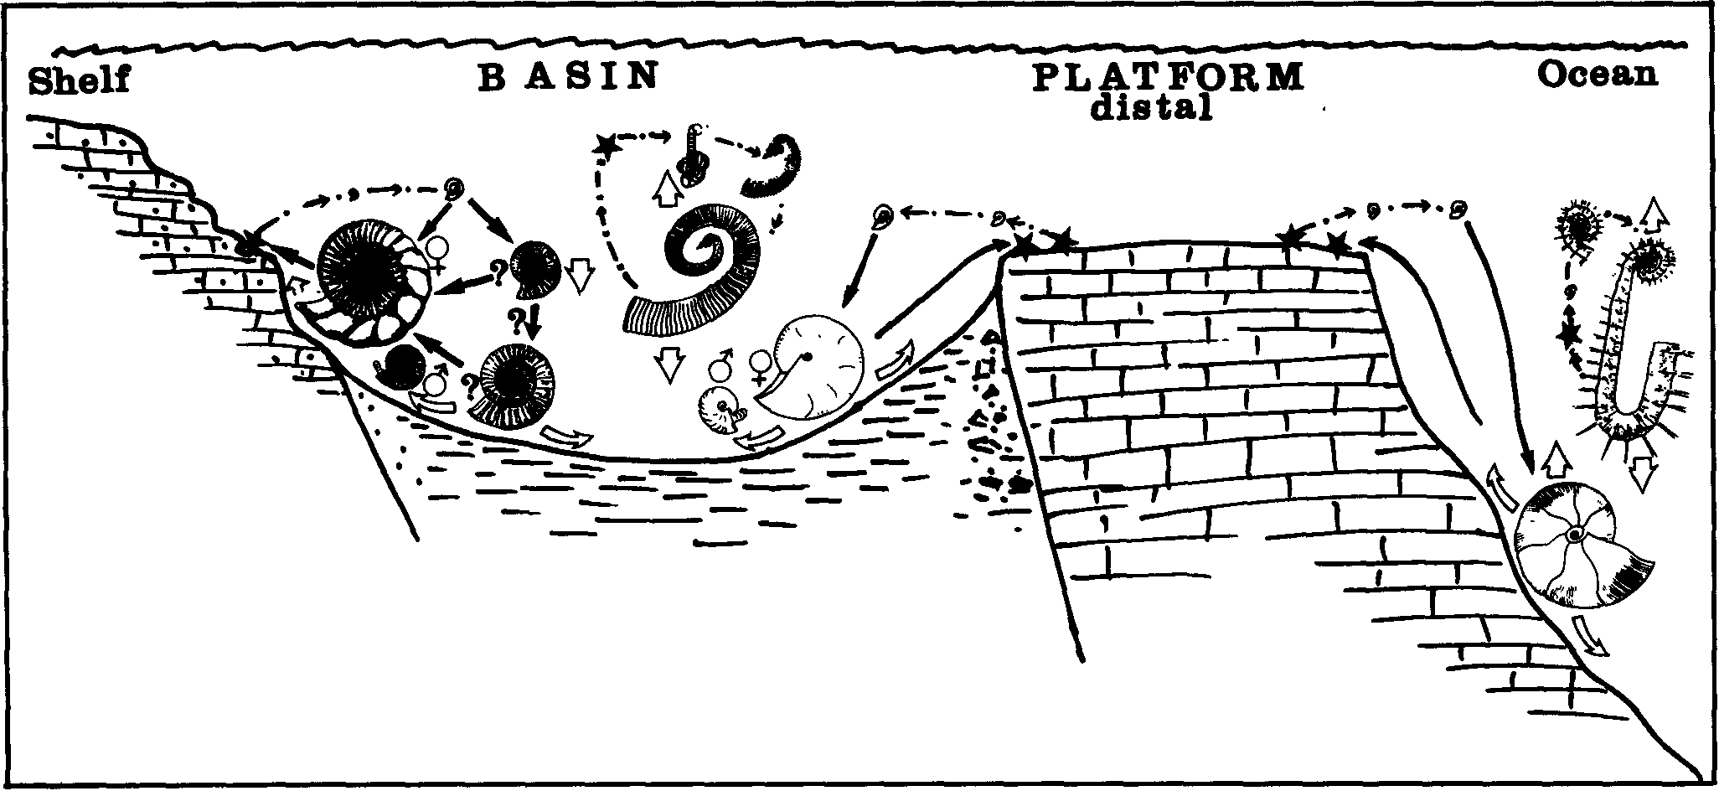
Fig. 8 - Possible life-cycles of Ammonitina, Phylloceratina and heteromorph Ancyloceratina (Lytoceratina presumably resembled Phylloceratina). Asteriscs indicate the eggs, here shown as pelagic in the planktonic heteromorphs, and on the shelf or distal platform in the nekto-benthic forms; dash-dot arrows indicate passive drift, solid arrows, active migration between life-cycles, and hollow arrows, feeding behaviour and diurnal migration. Some planulate ammonites with modified body chamber (left) may have had an extended pelagic stage (? one month), possibly followed sequentially by nekto-benthic basic and (proximal) platform stages. Males (microconchs) and females (macroconchs) probably lived segregated in many taxa for par of their life.

the two whorls between 1 mm (ammonitella) and 4 mm diameter total approximately 16 mm venter length(Hewitt, 1986). If the growth of the complete ammonite took, for example, 1000 days, a good average for neritic ammonites (see Ch. B4), then the estimated growth interval of the two juvenile whorls was 1000 x 16/520 = 50.7 days or 1 month. (Note that oceanic "leiostracans" and planktonic heteromorphs usually miss this separate growth stage and may form much more slowly, see Ch. B4).
The earliest whorls of most ammonites are as strong or stronger than the later stages (Hewitt, 1987; Hewitt & Westermann, 1987a) indicating at least similar water depths; not just an epipelagic habitat.

(b) Deep-epipelogic to mesopelagic passive drifters:
megaplankton (also neritic). Some heteromorphs, particularly the ancyloconic Diplomoceratids with open, non-spiralic shell. The darker, deeper water below wave base (~50/100-200 m) was probably preferred in order to minimize predation and shell breakage by turbulance. The jaw apparatus with radula at least in some (Scalarites) indicates feeding on megaplankton (~1 mm), perhaps including other ammonites, sluggish crustaceans, crinoids, nudibranchs, and medusae. Perhaps prey capture was by "shooting out" of long tentacles or by mucus nets containing a stunning poison. Other heteromorphs (without "beaks" and radula) may have been mucus-trap feeders (Nesis, 1987). Gyrocones are often associated and probably also pelagic, rather than nekto-benthic (Ward, 1976a).
(c) Epipelagtc nekton and nekto-benthos II: the Phylloceratid Holcophylloceras, with highly "streamlined" platyconic shell and only moderately strong septa and siphuncle; periodic true (shell surface) constrictions weaken the shell. With twin or extended hyponome according to aperture as indicated by constriction. Growth

apparently "unlimited" and without marked dimorphism. Found in shallower fades than Bl (Geczy, pers. commun., 1987) and prone to post-mortem drift into near-shore assemblages (Khimshiashvili, 1987 and pers. commun.).
2. Deep, aphotic zone (250-800 m). — Vertical migration is probably required, at least during growth, by the pressure limit on the "osmotic pump" at about 240 m depth.
(a) Mesopelagic nekton I, diurnal vertical migrants: Lytoceratids, with circular, advolute whorls, strong septa and connecting rings, shell weakly ornate except for body chamber (Stevens, 1985b), and periodic crinded flares; conical thin anaptychi are probably jaws. Hence feeding habit probably macro-or megaphagous. Found consistently together with Phylloceradds (A2b) in deep-water fades (for example, Tanabe, 1979; Hoedemaker, 1987).
(b) Bathyal, nekto-benthos II, probably facultative Mesopelagic nekton II and diurnal migrants (similar to Nautilus}: Most of the highly "streamlined" Phylloceratids, e.g. Phylloceras, Calliphylloceras, Ptychophylloceras, and moderately "streamlined" Tetragonitids with strong septa and connecting rings (Hewitt & Westermann, 1987); complicated, closely set sutures. Without constrictions, but some with pseudo-constrictions (internal test ridges); dense lirae or riblets. The Lamellaptychus, known from Ptychophylloceras, possibly a locomotor and (?) lid; but Tetragonits with calcified beaks in lower and upper jaws, as in Nautilus. Megaphagous predators and/(?) scavangers. Distribution suggests that Phylhceras was also distal neritic and cosmopolitan, including the margin of the Arctic basin (? ocean) (Poulton, 1987); but Ptychophylloceras and (?) Calliphylloceras, as well as the Tetragonitids, were typically oceanic.
B) NERITIC « 250 m), OFF-SHORE 1. Plankton. — Possibly some "pseudolarvae" and early

JURASSIC-CRETACEOUS AMMONOID ECOLOGY 475

juveniles (mostly Ammonitina and Ancyloceratina) as in oceanic biome (see above). Others may have remained hovering near the sea floor where they hatched perhaps in off-shore algae mats (Sturani, 1964).

2. Pelagic passive drifters (megaplankton)

(a) ? Serpenticones:
mainly the Dactylioceratids, with extremely long body chamber causing hydrostatic instability; "non-streamlined", with anaptychus and coleoid-type radula indicating megaphagy. Typically found in anoxic laminated shales which were deposited in rather shallow and warm water (? 50-100 m) (Kemper, 1987). Clade diversity is coincident with ubiquitous Early Toar-cian "black shales" (Hallam, 1987). The Dactylioceratids were, therefore, either shallow-water megaplankton, above the anoxic or dysoxic bottom waters (Tintant et al., 1982; but there represented in deep water); or very sluggish nekto-benthos within the dysaerobic bottom waters. In the first case the feeding habit remains unknown since their shell shape prevented active preda-tion; in the second, their near-neutral equilibrium permitted them to carry their shell at any orientation and to extend their long body a great distance (R. Jordan, pers. conunun., 1981; see Ch. D) for preying or scavenging on soft-bodied epibenthos during times of low base-level of oxygenated waters (Kauffman, 1981), while mass-mortality occurred (together with the associated Har-poceratids) during rising base-level.

(b) Non-helicalancylocones, vermiforms and perhaps some gyrocones and highly variable dwarfs:
small, variable Spiroceratids, previously considered as sessile (Lehmann, 1976; Died, 1978), but now interpreted as drifting among fixed or floating algae mats. The Early Cretaceous thick-shelled and coarsely ribbed forms lived in shallow, cool water (Ward, 1980; Kemper, 1987), but the almost homeomorphic Late Cretaceous Hamitids and Ancylocer-atids probably in deeper (? warmer) water. Often with complete lack of "streamlining" (Nipponites) and with ontogenetic change in orientation (Hamitids). Probably partly also oceanic, epi- to mesopelagic. Many of the deep-water drifters have several rows of long fragile spines for defense. Some have "jaws" and radula, indicating megaphygy (see also under Alb). The benthic habitat favoured for some or most forms by Lehmann (1971) and Klinger (1981) is therefore improbable.

(c) ? Highly variable spherocones to inflated "oxycones",
with extremely high intraspecific variation in shell shape and ornamentation (presumed nonfunctional): Possibly some Sphaeroceratids and Cardioceratids, with long body chamber indicating low stability; weak dimorphism, microconchs without lappets; and (?) no aptychi (for mobility and/or megaphagy).

3. Pelagic vertical migrants.

(a) (?) Torticones:

Turrilitids, with good vertical mobility due to vertical orientation of aperture — or benthic saltators (4b).

(b) Torticonic ancylocones:
Nostoceratids, with slow vertical mobility due to body chamber hook with aperture directed upwards. Immature shell as in torticones.

(c) Orthocones, circular cross-section:
Some Baculitids, highly stable with questionable lateral but rapid vertical (escape) mobility.

(d) (?) Scaphitoid heteromorphs (large body chamber hook):
Scaphitids, with multi-directional mobility — or partly nekto-benthic (D3).

4. Nekto-benthic I (sluggish)

(a) Orthocones, compressed-ovate cross-section:
Most Baculitids, highly stable with slow lateral but rapid vertical (escape) mobility.

(b) (?) Torticones:
Turrilitids, highly stable with slow lateral but rapid vertical (escape) mobility (benthic saltators) — and/or pelagic vertical migrants (3a).

(c) ? Scaphitoid spherocones (small bodychamber hook;
intermediate to ancylocones): Scaphites S.I., with well developed, calcified Striaptychus, a possible locomotor. Slow horizontal and vertical mobility is indicated; adult rather poorly streamlined but highly stable. Upturned aperture as in ancyloconic pelagic drifters and often restricted by approximation to phragmocone, suggesting feeding from water column (by ? mucus net); alternatively, long tentacles could have reached the substrate, while the up-turned aperture protected the soft-parts. Benthos dependence indicated by occurrance (Batt, 1987). Some microconchs much smaller than corresponding macroconchs and with lappets, suggestive for nekto-benthos. Septa and siphuncle moderately strong indicating intermediate depth (100-200 m). — Some corresponding microconchs, however, were more strongly ancyloconic, with large body chamber hook, and probably pelagic (A2). — Or pelagic vertical migrant (3d).

(d) Ornate planulates and coronates ("trachyostracans"):
Arietitids, Eoderoceratids, many Stephanoceratids and Perisphinctids, Reineckeiids, Acanthoceratids, Aspidocer-atids, etc. Sluggish to (?) moderately mobile. Usually strongly dimorphic; adult microconch bearing lappets and adult mmacroconch with thickened aperture, defences against (benthic) predators; also protected by prominent sculpture in both dimorphs. Post-Liassic forms with calcareous shovel-shaped aptychi, presumably mostly functioning as locomotors by producing water current for hyponome. In the very shallow-water Aspidoceratids, however, the thick Laevaptychus was probably (? mainly) a protective lid, perhaps containing chemo-repellant.
Among the shallowest (30-50 m) ammonites living in warm epicontinental seas were the "coronate" Jurassic Gravesia and the Cretaceous neoceratites with phyleti-cally simplified sutures. But all ammonites lived in relatively quiet waters off-shore (Taylor, 1982).
(e) ? Some serpenticones (see under 2 a).

5. Nekto-benthic II (mobile), ? facultative nektonic II, rather shallow to deep (?30, 50-250 m). — Many presumably prey on ammonites.

(a) Oxycones:
Many Graphoceratids, Sonniniids, Oxy-noticeratids, Clydoniceratids, Oppeliids, ect. Mainly the macroconchs are hydrodynamically very efficient and often with aspect ratio lower than in Nautilus; adult body chamber with egressing umbilical seam and rounded venter for improved stability. Low intraspecific variability. Strong dimorphism: microconchs usually much smaller, with lappets and much less "streamlined", often platyconic. Septal sutures vary form simple and distantly spaced to highly complicated and densely spaced. Many with Lamellaptychus which presumably served as a locomotor and (?) lid.
Most typically oxyconic Oppeliids inhabited deep nerit-ic waters (e.g. Oxycerites) (Wiedmann, 1973; Gygi, 1986), even to the margin of the continental slope (e.g.

476 FOSSILI, EVOLUZIONE, AMBIENTE - G.E.G. WESTERMANN

Uhligites); but the similar Clydoniceratids were in near-shore, shallow water (Marchand et al., 1985); keeled-fastigate forms, often finely ribbed (e.g. Oppelia) had habitats of intermediate depth; whereas the shallowest habitat was occupied by some Jurassic oxyconic Graphoceratids (Bayer & McGhee, 1984) and Cretaceous oxycones with pseudoceratic sutures (e.g. Sphenodiscids) found together with planulate neoceratites (4d).

(b) Oxycone-platycone intermediates:
Many of the keeled, moderately evolute Hildocerataceans (Harpocer-atinae, Grammoceratinae as well as some Hammatocera-tinae, Graphoceratinae and Sonniniidae) have fine ribbing which may have improved "streamlining"; the earliest strong dimorphism with lappet-bearing microconchs; and thinly calcified, hinged cornaptychi which possibly functioned as locomotor. They were presumably relatively good swimmers and fed mainly benthos. (Note that supposed ink-saks have now been re-interpreted as stomach; Lehmann, 1985).
(c) Some platycones: e.g. Haploceratids and the Phylloceratid Tragophylloceras, the former with heavy Lamellaptychus (? lid and/or locomotor); also the constricted, ornamented Lytoceratids Pachylytoceras and Pleurolytoceras. Dimorphism is well developed in these Lytoceratids (Callomon, 1981) and in Haploceratids (Enay & Cecca, 1986); sutures are simple to moderately complex. Habitat similar to 5a. Intermediate depth.
6. Deep Nekto-benthic and/or nektonic I-II, outermost neritic to (?) oceanic (200-300 m). — Pachydiscids and Desmocer-ataceans, i.e. involute-platyconic, bluntly ribbed heomeo-morphs of Phylloceratids. Often associated with true "leiostracans" (Tanabe, 1979); also with anaptychi, presumably jaws. The frequent blunt ribbing is possibly for protection from predators; ribbing may in some cases also improve hydrodynamic efficiency. Septa and connecting rings very strong; sutures complicated and narrowly spaced.

ACKNOWLEDGEMENTS
I thank Roger Hewitt, McMaster University, for many valuable suggestions. R.J. Batt, Hope College, N.H. Landmann, American Museum of Natural History, K. Bandel and U. Lehmann, Hamburg University, have critically read the manuscript draft. G.L. Voss, University of Miami, advised on living coleoids.
The Canadian Science and Engineering Research Council has financed the research.

REFERENCES
BACHMAYER, G., 1963 - Beitrage zur Palaontologie Oberjurassischer Riffe: Ann. Naturhist. Museum Wien, 66: 129-130. BANDEL, K., 1982 - Morphology and formation of the early on-
togenetic shells of conchiferan mollusks: Fades, 7: 1-198 (Er-
langen). BANDEL, K., 1987 - Operculum and buccal mass of ammonites: in:
Cephalopods - present and past. J. Wiedmann and J. Kullman,
(eds.), Cephalopods, present and pasta. Schwei2erbarts'sche Ver-
lagsbuchhdig. (Stuttgart), pp. 215-228. BANDEL, N.H., LANDMAN & K.M. WAAGE, 1982 - Microorna-
ment on early whorls of Mesozoic ammonites: implications for
early ontogeny: J. Paleont., 56: 386-391. BATT, R.J., 1986 - A test of the effects of paleoecological factors

of the distribution of ammonite shell morphotypes, Greenhorn Cyclothem, Cretaceous Western Interior Seaway. In: E.G. KAUFFMAN, ed.. Cretaceous biofacies of the central part of the Western Interior Seaway: a field guidebook, pp. 16-52,4th North Amer. Paleont. Conv., 1986. Dept. Geol. Sci., CB-20 Univ. Colorado, Boulder.
BATT, R.J., 1987 - Pelagic biofacies of the Western Interior Greenhorn Sea (Cretaceous). Evidence from ammonites and planktonic Foraroiniferas. Unpublished Ph. D. thesis, Univ. Colorado, Boulder, 778 p.p.
BAYER, U., 1970 - Anomalien bei Ammoniten des Aaleniums und Bajociums und ihre Beziehung zur Lebensweise: N. Jb. Geol. Palaont., Abh. 135: 19-41.
BAYER, U. & G. MCGHEE, 1984 - Iterative evolution of Middle Jurassic ammonite faunas: Lethaia, 17: 43-51.
CALLOMON, J.H., 1985 - The evolution of the Jurassic ammonite family Cardioceratidae: Spec. Paps. Palaeont., 33: 49-90.
CARIOU, E., D. CONTINI, J.L. DOMMERGUES, R. ENAY, J. GEYSSANT, C. MANGOLD &J. THIERY, 1985 - Biogeographie des ammonites et evolution structurale de la Tethys aucours du Jurassique: Bull. Soc. Geol. France, Ser. 8, 1: 679-697.
CHAMBERLAIN, J.A., Jr., 1976 - Flow patterns and drag coefficients of cephalopod shells: Palaeontology, 19: 539-563.
CHAMBERLAIN, J.A., 1981 - Hydromechanical design of fossil Cephalopods. In: HOUSE, M.R. and J.R. SENIOR, (eds.): The Ammonoidea, p.p. 289-336: Syst. Ass. Spec. Vol. 18.
CHAMBERLAIN, J.A. & W.A. MOORE, Jr., 1982 - Rupture strength and flow rate of Nautilus siphuncular tube: Paleobiology, 8:
408-425.
CHAMBERLAIN, J.A., P.D. WARD &J.S. WEAVER, 1981 - Postmortem ascent of Nautilus shells implications for cephalopod paleobiogeography: Paleobiology, 7: 494-509.
CHAMBERLAIN, J.A. & G.E.G. WESTERMANN, 1976 -Hydrodynamic properties of cephalopod shell ornament: Paleobiology, 4: 316-331.
CHECA, A., 1985 - Los Aspidaceratiformes en Europa (Ammoniti-na. Faun. Aspidoceratidae: Subfamilies Aspidoceratinae y Phys-odoceratinae). Thesis, Fac. Cien., Univ. Granada, 411 p.
COCHRAN, J., & N. LANDMANN, 1984 - Radiometric determination of the growth rate of Nautilus in nature: Nature, 308:
725-727.
DIETL. G., 1978 - Die heteromorphen Ammoniten des Dogger (Stratigraphie, Taxonomie, Phylogenie, Okologie): Stuttgarter Beitr. Naturk., B, 33: 1-97.
DIETL. G., 1981 - Uber Paracuariceras und andere heteromorphe Ammoniten aus dem Macrocephalen-Oolith (Unter-Callovimn, Dogger) des SchwabischenJuras: Stuttgarter Beitr. Naturk., B, 76: 1-15.
DOGUZHAEVA, L. & H. MUTVEI, 1986, Functional interpretation of inner shell layers in Triassic ammonites: Lethaia, 19:
195-209.
DONOVAN, D.T., 1985 - Ammonite shell forms and transgression in the British Lower Lias. In: FRIEDMAN, G.M. (ed.), Lecture Notes in Earth Sciences 1. Sedimentary and Evolutionary Cycles, p.p. 48-57, Springer-Verlag.
FRIEDMAN, G.M., 1987 - Evolution of the Arietitidae and their descendants: Cahiers Inst. Catho. Lyon, ser Sci., 1: 123-138.
DZIK, J., 1981 - Origin of the Cephalopoda: Acta Palaeont. Pol-on., 26: 161-191.
EBEL, K., 1983 - Berechnungen zur Schwebefahigkeit der Ammoniten: N. Jb. Geol. Palaont., Mh. 1983 (10): 614-640.
EBEL K., 1985 - Gehausespirale und Septenform bei Ammoniten unter Annahme vagil benthonischer Lebensweise: Palaont. Z., 59: 109-123.
ELMI, S., 1985 - Influence des haut-fonds sur la composition des peuplements et sur la dispersion des ammonites: Bull. Sect. Sci., T. 9, Geol. Geodyn. Senils Haut-fonds, p.p. 217-228, Minist. Educ. Natl. Comm. Trav. Hist. Sci. (Paris).
ELMI, S. & Y. ALMERAS, 1984 - Physiography, paleotectonics and paleoenvironments as controls of changes in ammonite and brachiopod communities (an example from the Early and Middle Jurassic of Western Algeria): Palaeogeog. Palaeoclim. PalaeoecoL, 47: 347-360.

JURASSIC-CRETACEOUS AMMONOID ECOLOGY 477

ENAY, R. & F. CECCA, 1986 - Structure et evolution des populations tithoniques du genre d'ammonites tethysien Haplocerus Zit-td, 1868. Att. 1 Conv. Pergola 25-28 Oct. 1984: Fossili Evoluzi-one Ambiente, p.p. 37-62. Corn. Center, R. Piccinini.
FISCHER, A.G. & FAY P.O., 1953 - A spiny aptychus from the Cretaceous of Kansas: State Geol. Surv. Kansas Bull., 102: 77-92.
GYGI, R.A., 1986 - Eustadc sea level changes in the Oxfordian (Late Jurassic) and their effect documented in sediments and fossil assemblages of an epicontinental sea: Ed. Geol. Hdv., 79: 455-491.
HALLAM, A., 1987 - Radiations and extinctions in relation to environmental change in the marine Lower Jurassic of Europe:
Paleobiology, 13: 152-168.
HENDERSON, R.A., 1984 - A musde attachment proposal for sep-tal function in Mesozoic ammonites: Palaeontology, 27: 461-486.
HENGSBACH, R., 1978 - Bemerkungen fiber das Schwimmvermo-gen der Ammoniten und die Funktion der Septen: Sitzungsber. Ges. Naturf. Freunde Berlin, N.F., 18: 105-117.
HENGSBACH, R., 1979 - Zur Kenntnis der Asymmetrie de Ammoniten-Lobenlinie: Zool. Beitr., N.F., 25: 107-162.
HENGSBACH, R., 1986 - ZurKenntnis der Sutur-Asymmetrie bei Ammoniten: Senckenbergiana Lethaea, 67: 119-149.
HEWITT, R.A., 1985 - Numerical aspects of sutural ontogeny in the Ammonitina and Lytoceratina: N. Jb. Geol. Palaont., Abh. 170: 273-290.
HEWITT, R.A., 1986 - Terminology of ammonid coiling equation:
Lethaia, 19: 338.
HEWITT, R.A., 1987 - Significance of early septal ontogeny in am-monoids and other ectochochliates. In: Cephalopods - present and past, J. Wiedmann & J. Kullmann (eds.), Schweizerbart (Stuttgart).
HEWITT, R.A. & G.E.G. WESTERMANN, 1986 - Function of complexly fluted septa in ammonoid shells. I. Mechanical prindple and functional models: N. Jb. Geol. Palaont., Abh. 172: 47-69.
HEWITT, R.A. & G.E.G. WESTERMANN, 1987a - Function of complexly fluted septa in ammonoid shells. II. Septal evolution and condusions: N. Jb. Geol. Palaont., Abh. 174: 135-169.
HEWITT, R.A. & G.E.G. WESTERMANN, 1987b - Stress and strain in Nautilus shells: some limitations on the buoyancy control and vertical migration of ectocochliates. In: Cephalopods - present and past, J. Wiedmann and J. Kullmann (eds.), Cephalopods, present and past. Schweizerbart'sche Verlagsbuchhidg, (Stuttgart), pp. 705-712.
HEWITT, R.A. & G.E.G. WESTERMANN, 1987c - Shell Architecture. In: W.B. SAUNDERS and N. LANDMANN (eds.). Nautilus, biology and paleobiology of a living fossil. Plenum Press.
HEWITT, R.A. & G.E.G. WESTERMANN, 1988a - Nautiloid septal strength: revisited and revised concepts: Alchiringa 12:
123-128.
HEWITT, R.A. & G.E.G. WESTERMANN, 1988b - Buckling phenomena in cephalopod phragmocones and the musde attachment proposal for septal function in Mesozoic ammonites: Historical Geology.
HKANO, H. & Y. KANIE, 1980 - The jaw apparatus of Scalarites mihoensis, a Late Cretaceous Cretaceous ammonite: Prof. Sab. Kenuo Mem. Vol., p.p. 159-165.
HOEDEMAKER, H.J., 1987 - Remains of early Cretaceous ammonites and of a fish from Deep Sea Drilling Project site 603. In: Hinte, J.E., S.W. Wiese, Jr. et al.. Initial Reports of Deep Sea Drilling Project, Vol. 32, Washington.
JORDAN, R., 1968 - Zur Anatomic mesozoischer Ammoniten nach den Strukturdementen der Gehause-Innenwarnd: Beihefte Geol. Jb., Helf 77: 1-64.
KAUFFMAN, E.G., 1981 - Ecological reappraisal of the German posidonienschiefer (Toarcian) and the stagnant basin model. In:
Gray, J. A.J. Boucot & W.B.N. Berry (eds.): Communities of the past, p.p. 311-38, Hortchisson Ross, Stroudsburg, Pennsylvania.
KEMPER, E., 1987 - Das Klima der Kreide-Zdt: Geol. Jb., A. Heft 96, 349 p.
KEMPER, E. & K. WIEDENROTH, 1987 - Klima und Tier-Migrationen am Bdspid der Fruhkretazischen Ammoniten Nord-westdeutschlands. In E. KEMPER (ed.), Das Klima der Kreide-Zeit. II, Beitrage sur Klima-Analyse der Kreide: Geol. Jb., A.

Heft 96: 315-364.
KENNEDY, W.J. & W.A. COBBAN, 1976 - Aspects of ammonite biology, biogeography and biostratigraphy: Spec. Papers Palaeont., 17: 1-94.
KHIMSHIASHWILI, N.G., 1987 - Ecology of some Tethyan Callo-vian ammonites. Abstract, this conference.
KLINGER, H.C., 1981 - Speculations on buoyancy control and ecology in some heteromorph ammonites. In: HOUSE, M.R. &J.R. SENIOR (eds.), The Ammonoidea: Syst. Ass. Spec. Vol. 18:
337-355.
KULICKI, C., 1974 - Remarks on the embryolonal devdopment of ammonites: Acta Palaeont. Polon., 29: 201-224.
KULICKI, C. & A. WIERZBOWSKI, 1983 - The Jurassic juvenile ammonites of the Jagua Formation, Cuba: Acta Plaeont. Pol-on., 28: 369-384.
KUUCKI, C., L.A. DOGUZHAEVA & G.K. KABANOV, 1987 - Nautilus like jaw dements of a juvenile ammonite. In: Cephalopods - present and past, J. Wiedmann &J. Kullmann (eds.): Schweizer-bart'sche Verlagsbuchhidg. (Stuttgart), pp. 679-686.
KUTEK, J. & A. WIERZHOWSKI, 1986 - A new account of Upper Jurassic stratigraphy of the Czorsztyn succession. Piening Klip-pen Belt, Poland: Acta Geol. Polon., 36: 289-316.
LANDMAN, N.H., 1987 - Ontogeny of Upper Cretaceous (Turonian-Santonian) scaphitid ammonites from the Western Interior of North America: Systematics, developmental patterns, and life history: Bull. Amer. Mus. Nat. Hist. New York, 185 (2):
117-279.
LANDMANN, N.H. & K. BANDEL, 1985 - Internal structures in the early whorls of Mesozoic ammonites: Amer. Mus. Novitates, 2823: 1-21.
LANDMANN, N.H. & A. WAAGE, 1986 - Shell abnormalities in scaphitid ammonites: Lethaia, 19: 211-224.
LEHMANN, U., 1972 - Aptychen als Kieferdemente der Ammoniten:
Palaont. Z., 46: 34:48.
LEHMANN, U., 1975 - Uber Nahrung und Emahrungweise von Ammoniten: Palaont. Z., 49: 187-195.
LEHMANN, U., 1976 - Ammoniten, 171 p. Ferdinand Enke (Stuttgart).
LEHMANN, U., 1981 - Ammonite jaw apparatus and soft parts: In:
HOUSE, M.R. andJ.R. SENIOR (eds.): The Ammonoidea. Syst. Ass. Spec. Vol. 18: 275-287.
LEHMANN, U., 1985 - Zur Anatomic der Ammoniten: Tintenbeu-td, Kiemen, Augen: Palaont. Z., 59: 99-108.
LEHMANN, U., 1987 - On dietary habits and locomotion of fossil Cephalopods, In: Cepahlopods - past and present, p.p. 633-640, J. Wiedmann & J. Kullman (eds.), Scheizerbart (Stuttgart).
LEHMANN, U., K. TANABE, Y. KANIE & Y. FUKUDA, 1980 -Uber den Kieferapparat der Lytoceratacea (Ammonoidea):
Palaont. Z., 54: 319-329.
LOWENSTAM, H.A., W. TRAUP & S. WEINER, 1984 - Nautilus hard parts: a study of the mineral and organic consituents: Paleobiology, 10: 268-279.
MAPES, R.H. & D.A. SNECK, 1987 - The oldest ammonoid 'coulor' patterns: descriptions, comparisons with Nautilus, and implications: Palaeontology, 30: 299-309.
MARCHAND, D.,J. THIERRY & H. tintant, 1985 - Influence des seuils et des haut-fonds sur la morphologic et 1'evolution des am-monoides: Bull. Sect. Sd. (Lyon), 9: 191-202.
MARCINOWSKY, R. & J. WIEDMANN, 1985 - The Albian ammonite fauna of Poland and its paleogeographic significance: Acta Geol. Polon., 35: 199-219.
MEHL, J., 1984 - Radula und Fangarme bei MicheSnoceras sp. aus dem Silur von Bolivien: Palaont. Z., 58: 211-229.
MORTON, N., 1981 - Aptychi: the myth of the ammonite opercu-lum: Lethaia, 14: 57-61.
MORTON, N. & M. NIXON, 1987 - Size and function of ammonite aptychi in comparison with buccal masses of modern cephalo-pods: Lethaia, 20: 221-238.
MUTVEI, H. & R.A. REYMENT, 1973 - Buoyancy control and siphuncle function in ammonoids: Paleontology, 16: 623-636.
NESIS, K.N., 1986 - On the feeding and causes of extinction of certain heteromorph ammonites: Paleont. Zhur. 1986: 8-15 (Transl. Paleont. J., 20: 5-11. Scripta Techn. 1987).

478 FOSSILI, EVOLUZIONE, AMBIENTE - G.E.G. WESTERMANN

POULTEN, T.P., 1987 - Zonatian and correlation of Middle Boreal Bathonian to Lower CaUovian Jurassic) ammonites, Salma Cache Canyon, Porcupine River, Northern Yukon: Geol. Sur. Can., BuU. 358: 1-155.
SARTI, C., 1987 - Dimorfismo neUa spede Swerbyceras loryi (Mun. - Chlm.) del Kimmeridgiano, Abstract, this conference.
SAUL, L.K., 1979 - A hollow spined Anapachydiscus peninsularis with possible Mosasaur bite impression: Contrib. Sd. Naturhist. Inst. Mus. Los Angeles Country, 1979: 1-8.
SAUNDERS, W.B., 1964 - Nautilus growth and longevity: Evidence from marked and recaptued animals: Science, 224: 990-992.
SAUNDERS, W.B. & E.A. SHAPIRO, 1986 - Calculation and simulation of ammonoid hydrostatics: Paleobiology, 12: 64-79.
SAUNDERS, W.B. & A.R.H. SWAN, 1984 - Morphology and am-monoids in time and space: Paleobiology, 10: 195-228.
SCHINDEWOLF, O.H., 1958 - Uber Aptychen (Ammonoidea):
Palaeontographica, Abt. A, 111: 1-46.
SEQUIEROS, L., 1984 - Fades y ammonoideos de edad Calloviense al sar de Zaragoza (Cordillera Iberica): Bol. Geol. Miner., 95-2:
109-115.
STEVENS, G.R., 1985a - Giant Ammonites (Extended abstract), Hornibrook Symposium: New Zealand Geol. Surv., Rec. 9: 84-86.
STEVENS, G.R., 1985b - A revision of the Lytoceratinae (Subclass Ammonoidea) including Lytoceias taharoaense a. sp.. Upper Jurassic, New Zealand: New Zealand J. Geol. Geophys., 28:
1153-1185.
STENZEL, H.B., 1964 - Living Nautilus. In: Treatise on Invertebrate Paleontology, R.C. Moore (ed.). Part K., Mollusca 3: 59-93, Geol. Soc. Amer. & Univ. Kansas Press (Kansas).
STURANI, L., 1964 - La successione delle faune ad ammoniti nelle formazioni mediogiurassiche delle Prealpi Venete ocddentali: Mem. Inst. Geol. Mineral., Univ. Padova, 24: 1-64.
STURANI, L., 1967 - Ammonites and stratigraphy of the "Posido-nia alpina" beds of the Venetian Alps: Mem. 1st. Geol. Min. Univ. Padova, 28: 1-190.
SWAN, A.R.H. & W.B. SAUNDERS, 1987 - Function and shape in late Paleozoic (mid-Carboniferous) anunonoids: Paleobiology, 13: 297-311.
TANABE, K., 1977 - Functional evolution of Otoscaphites puercu-lus (Jimbo) and Scaphites planus (yabe). Upper Cretaceous ammonites: Mem. Fac. Sd. Kyushi Univ. D, Geol., 32: 367-407.
TANABE, K., 1979 - Palaeoecological analysis of ammonoid assemblages in the Turonian Scaphites fades of Hokkaido, Japan:
Palaeontology, 22: 609-630.
TANABE, K., 1983 - The jaw apparatus of Cretaceous desmocer-atid ammonites: Palaeontology, 26: 677-688.
TANABE, K. & Y. FUKUDA, 1983 - Buccal mass structure of the Cretaceous ammonite Gaudryceras: Lethaia, 16: 249-256.
TANABE, K. & Y. FUKUDA, 1987 - The jaw apparatus of the Cretaceous ammonite Reesidites: Lethaia, 20: 41-48.
TANABE, K., Y. FUKUDA, Y. KANIE & U. LEHMANN, 1980 -Rhyncholites and conchorhynchs as calcified jaw elements in some late Cretaceous ammonites: Lethaia, 13: 157-168.
TANABE, K. & Y. OHTSUKA, 1985 - Ammonoid early internal shell structure: its bearing on early life history: Paleobiology, 11:
310-322.
TAYLOR, D.G., 1982 - Jurassic shallow marine invertebrate depth zones with eximplification from Snowshoe Formation, Oregon:
Oregon Geol., 44: 51-56.
TINTANT, H., D. MARCHAND & R. MOUTERDE, 1982 - Relations entre Ie milieu marin et 1'evolution des Ammonites: les radiations adaptives du Lias: Bull. Soc. Geol. France, 25:
951-961.
WARD, P.D., 1976a - Stratigraphy, paleoecdogy and functional morphology of heteromorph ammonites of the Upper Cretaceous Nanaimo Group, British Columbia and Washington: unpubl. Ph. D. Thesis, McMaster University, Department of Geology, Hamilton, Canada.
WARD, P.D., 1976b - Upper Cretaceous ammonites (Santonian-Campanian) from Orcas Island: Washington J. Paleont., 50: 454-461.
WARD, P.D., 1979 - Functional morphology of Cretaceous helically-

coiled ammonite shells: Paleobiology, 5: 415-422.
WARD, P.D., 1980 - Comparative shell shape distribution in Jurassic-Cretaceous ammonites and Jurassic-Tertiary nautilids: Paleobiology, 6: 32-43.
WARD, P.D., 1981 - Shell sculpture as a defensive adaptation in anunonoids: Paleobiology, 7: 96-100.
WARD, P.D., 1982 - The relationship of siphunde size to emptying rates in chambered cephalopods: implications for cephalo-pod paleobiology: Paleobiology, 8: 426-433.
WARD, P.D., 1985a - Upper Cretaceous molluscan faunal associations, British Columbia. In: Sedimentary and evolutionary cycles., U. BAYER and A. SEILACHER (eds.), Springer Verlag, p.p. 397-420.
WARD, P.D., 1985b - Periodidty of chamber formation in chambered cephalopods: evidence from Nautilus macromphalus and Nautilus pompilius: Paleobiology, 11: 438-450.
WARD, P.D., 1986 - Cretaceous ammonite shell shapes: Malacolo-gia, 27: 3-28.
WARD, P.D. & S.V. BOLETZKY, 1984 - Shell implosion depth and implosion morphologies in three spedes of Septa (Cephalopoda) from the Mediterranean Sea: J. Mar. Biol. Ass. U.K., 64:
955-966.
WARD, P.D. & SIGNOR in, P.W., 1983 - Evolutionary tempo in Jurassic in Cretaceous ammonites: Paleobiology, 9: 183-198.
WARD, P.D. & G.E.G. WESTERMANN, 1975 - First occurrance, systematics and functional morphology of Nipponites from the Americas: J. Paleont., 51: 367-372.
WARD, P.D. & G.E.G. WESTERMANN, 1985 - Cephalopod paleoe-cology. In: Mollusks, Notes for a short course, BROADHEAS, T.W. (ed.): Univ. Tennessee, Dept. Geol. Sd., Stud. Geol. 13:
215-229.
WEITSCHAT, W., 1986 - Phosphatisierte Ammonoidcen aus der Mittleren Trias von Central-Spitzbergen: Mit. Geol. Palaont. Inst. Univ. Hamburg, Heft 61: 249-279.
WENDT, J., 1971 - Genese und Fauna submariner Spaltenfullun-gen im mediterranenJura: Palaeontographica, A., 136: 121-191.
WESTERMANN, G.E.G., 1954 - Monographic der Otoitidae (Ammonoidea): Bern. Geol. Jb. (Hannover), Heft 15: 1-364.
WESTERMANN, G.E.G., 1966 - Covariation and taxonomy of the Jurassic ammonite Sonninia adicra (Waagen): N. Jb. Geol. Palaont., Abh. 124: 289-312.
WESTERMANN, G.E.G., 1969 - The ammonite fauna of the Koialagvik Formation at Wide Bay Alaska Peninsula. Part II. Sonninia sowerby Zone (Bajodan): Bull. Amer. Paleont., 57:
1-172.
WESTERMANN, G.E.G., 1971 - Form, structure and function of shell and siphunde in coiled Mesozoic anunonoids: Life Sd. Contrib. R. Ontario Mus., 78: 1-39.
WESTERMANN, G.E.G., 1973 - Strength of concave septa and depth limits of fossil cephalopods: Lethaia, 6: 383-403.
WESTERMANN, G.E.G., 1975 - A model for origin, function and fabrication of fluted cephalopod septa: Palaont. Z., 49: 235-253.
WESTERMANN, G.E.G., 1977 - Form and function of orthoconic cephalopod shells with concave septa: Paleobiology, 3: 300-321.
WESTERMANN, G.E.G., 1982 - The connecting rings of Nautilus and Mesozic ammonoids: implications for ammonite bathymetry: Lethaia, 15: 323-334.
WESTERMANN, G.E.G., 1985 - Exploding Nautilus camerae does not test septal strength index: Lethaia, 18: 348.
WIEDMANN, J., 1969, Phylogeny der Krdde-Heteromorphen. Biol. Rev., 44: 563-602.
WIEDMANN, J., 1972 - Ammoniten-NukId aus Schlammproben der nordalpinen Obertrias — ihre stammesgeschichtliche und stratigraphische Bedeutung: Mitt. Ges. Geol. Bergbaustud., 21:
561-622. (Wien).
WIEDMANN, J., 1973 - Evolution and revolution of ammonoids at Mesozoic system boundaries: Biol. Rev., 48: 159-194.
ZAKHAROV, Y. & T.A. LOMINADZE, 1983 - New data on the jaw apparatus of fossil cephalopods: Lethaia, 16: 67-78.
ZIEGLER, B., 1967 - Anunoniten-Okologie am Beispiel des Ober-jura: Geol. Rundschau, 56: 439-467.
ZIEGLER, B., 1981 - Ammonoid biosttatigraphy and provindalism:
Jurassic — Old World. In: The Ammonoides, HOUSE, M. & J.R. SENIOR (eds.): Syst. Ass. Spec. Vol. 18: 433-457.

